APPENDIX C
CRLF Habitat Site Assessment Data Sheets
Site Assessment reviewed by:
(FWS Field Office) |  |  |  |  |  |  |  | (Date) |  |  |  |  |  |  |  |  |  |  | (Biologist)
Date of Site Assessment: |  |  |  |  |  |  |  | 9/24/2007
 |  |  |  |  |  |  |  | (mm/dd/yyyy)
Site Assessment Biologists |  |  |  |  |  |  |  | Yarnell, Sarah
 |  |  |  |  |  |  |  | (Last name) |  |  |  |  |  |  | (First Name) |  |  |  | (Last name) |  |  |  | (First Name)
 |  |  |  |  |  |  |  | (Last name) |  |  |  |  |  |  | (First Name) |  |  |  | (Last name) |  |  |  | (First Name)
Site Location: |  |  |  |  | Placer County American Canyon Creek (at Middle Fork American River Mile 6.4) 10S 678261 / 4311623
 |  |  |  |  | (County, general location name, GPS coordinates)
**ATTACH A MAP (include habitat types, important features, and species location)**
Proposed project name: |  |  |  |  |  |  | Placer County Water Agency – Middle Fork American River Project
Brief description of proposed action:

PCWA owns and operates the MFP, a multi-purpose water supply and hydroelectric project designed to control and conserve waters of the Middle Fork American River, the and Rubicon River, and several associated tributary streams. The MFP system consists of two major storage reservoirs, five smaller regulating reservoirs and diversion pools, and five powerhouses and supplies water for homes, industry, and agriculture within western Placer County. PCWA operates the MFP under the terms of the FERC License No. 2079. The current license will expire on February 28, 2013, and PCWA will be seeking a new license for the MFP pursuant to the FERC’s ILP regulations.

1) Is this site within the current or historic range of the CRF (circle one) |  |  |  |  |  |  |  |  |  |  |  |  |  |  |  |  |  |  |  |  |  |  | Yes | No
2) Are there known records of CRF within 1.6 km (1 mi) of the site (circle one) |  |  |  |  |  |  |  |  |  |  |  |  |  |  |  |  |  |  |  |  |  |  | Yes | No
If yes, attach a list of all known CRF records with a map showing all locations.

GENERAL AQUATIC HABITAT CHARACTERIZATION

(If multiple ponds or streams are within the proposed action area, fill out one data sheet for each)

POND HABITAT:

Size: |  |  |  |  |  |  |  |  |  |  |  |  |  | Maximum depth:
Vegetation: emergent, overhanging, dominant species:
Substrate:
Perennial or Ephemeral (circle one) |  |  |  |  |  |  |  |  |  |  | If ephemeral, date it goes dry:
STREAM HABITAT:

Width (bank full): |  |  |  |  |  |  |  | ~ 6 feet
Depth (bank full): |  |  |  |  |  |  |  | ~ 3 feet
Stream gradient (percent slope): |  |  |  |  |  |  |  |  |  | <1 %
Are there pools (circle one): |  |  |  |  |  |  |  | Yes |  |  |  | No
 |  | If yes,
 |  | Size of stream pools: |  |  |  |  |  |  | 15 to 35 feet in length
 |  | Maximum depth of stream pools: |  |  |  |  |  |  |  |  |  |  |  | 2. 5 feet
Characterize non-pool habitat: run, riffle, glide, other: |  |  |  |  |  |  |  |  |  |  |  |  |  |  |  |  | Sections of cobble runs alternate
with steeper bedrock cascades and pools.
Vegetation: emergent, overhanging, dominant species: |  |  |  |  |  |  |  |  |  |  |  |  |  |  |  | Riparian vegetation is patchy along
the water’s edge, and was dominated by small to medium-sized willow shrubs and alder trees.
No emergent or aquatic vegetation present
Substrate: |  |  |  | Bedrock and cobble
Bank description: |  |  |  |  |  | The stream is confined within deep canyon walls and a bedrock channel
Perennial or Ephemeral (circle one) |  |  |  |  |  |  |  |  |  |  |  |  | If ephemeral, date it goes dry:
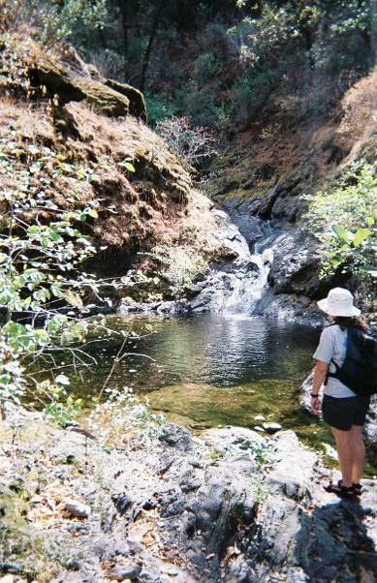
Other aquatic habitat characteristics, species observations, drawings, or comments:

California Red-Legged Frog Habitat Site Assessment Data Sheet

Site Assessment reviewed by:
(FWS Field Office) |  |  |  |  | (Date) |  |  |  |  | (Biologist)
Date of Site Assessment: |  |  |  |  | 5/17/2007, 6/5/2007, and 8/23/2007
 |  |  |  |  | (mm/dd/yyyy)
Site Assessment Biologists |  |  |  |  | Gonsolin, Earl |  |  |  |  | VanDellen, Chet
 |  |  |  |  | (Last name) |  |  | (First Name) |  | (Last name) |  |  | (First Name)
 |  |  |  |  | Buck, Christina
 |  |  |  |  | (Last name) |  |  | (First Name) |  | (Last name) |  |  | (First Name)
Site Location: |  |  | Placer County, Todd Creek, 10 S 679869 / 4314562
 |  |  | (County, general location name, GPS coordinates)
**ATTACH A MAP (include habitat types, important features, and species location)**
Proposed project name: |  |  |  | Placer County Water Agency – Middle Fork American River Project
Brief description of proposed action:

PCWA owns and operates the MFP, a multi-purpose water supply and hydroelectric project designed to control and conserve waters of the Middle Fork American River, the and Rubicon River, and several associated tributary streams. The MFP system consists of two major storage reservoirs, five smaller regulating reservoirs and diversion pools, and five powerhouses and supplies water for homes, industry, and agriculture within western Placer County. PCWA operates the MFP under the terms of the FERC License No. 2079. The current license will expire on February 28, 2013, and PCWA will be seeking a new license for the MFP pursuant to the FERC’s ILP regulations.

1) Is this site within the current or historic range of the CRF (circle one) |  |  |  |  |  |  |  |  |  |  |  |  | Yes | No
2) Are there known records of CRF within 1.6 km (1 mi) of the site (circle one) |  |  |  |  |  |  |  |  |  |  |  |  | Yes | No
If yes, attach a list of all known CRF records with a map showing all locations.

GENERAL AQUATIC HABITAT CHARACTERIZATION

(If multiple ponds or streams are within the proposed action area, fill out one data sheet for each)

POND HABITAT:

Size: |  |  |  |  |  |  | Maximum depth:
Vegetation: emergent, overhanging, dominant species:
Substrate:
Perennial or Ephemeral (circle one) |  |  |  |  |  | If ephemeral, date it goes dry:

STREAM HABITAT:

Width (bank full): |  |  |  | 10 feet
Depth (bank full): |  |  |  | .5 to 1.5 Feet
Stream gradient (percent slope): |  |  |  |  |  | 5%
Are there pools (circle one): |  |  |  | Yes |  |  | No
 | If yes,
 | Size of stream pools: |  |  |  | 15-25 feet in length
 | Maximum depth of stream pools: |  |  |  |  |  |  |  | 2.5 feet
Characterize non-pool habitat: run, riffle, glide, other: |  |  |  |  |  |  |  |  |  |  | Non-pool habitats include cascades
and runs
Vegetation: emergent, overhanging, dominant species: |  |  |  |  |  |  |  |  |  | No emergent or floating vegetation.
Riparian vegetation downstream of Driver’s Flat Road was dominated by small to medium-sized
willow and alder trees and shrubs. Canopy cover along the stream margins was generally
less than 25%, but up to 100% in some areas
Substrate: |  | Bedrock, boulder, and cobble
Bank description: |  |  | Stream is bedrock-confined, so backwater or secondary channels
Perennial or Ephemeral (circle one) |  |  |  |  |  |  |  | If ephemeral, date it goes dry: |  |  |  | Dry on 8/23/2007
Other aquatic habitat characteristics, species observations, drawings, or comments:

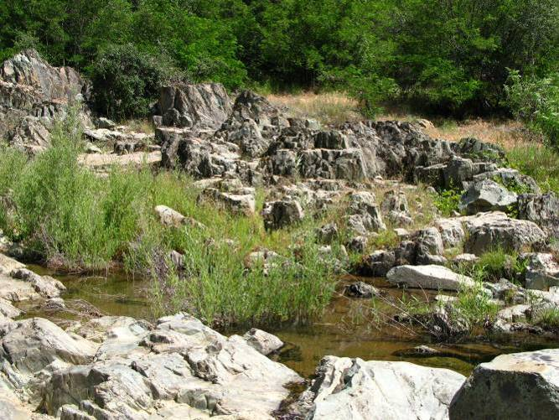
Stream channel near the Middle Fork American was approximately 3 m wide, with an adjacent floodplain along both banks. Upstream of Drivers Flat Road, valley width decreased, and the channel was confined within steep canyon walls. Spring flows were less than 1 cfs. The creek was dry during the fall (August) surveys. Non-native aquatic predators not observed.

California Red-Legged Frog Habitat Site Assessment Data Sheet

Site Assessment reviewed by:
(FWS Field Office) |  |  |  |  | (Date) |  |  |  |  | (Biologist)
Date of Site Assessment: |  |  |  |  | 5/17/2007, 6/5/2007, and 8/23/2007
 |  |  |  |  | (mm/dd/yyyy)
Site Assessment Biologists |  |  |  |  | Graff, Peter |  |  |  |  | Freiermuth, Brian
 |  |  |  |  | (Last name) |  |  | (First Name) |  | (Last name) |  |  | (First Name)
 |  |  |  |  | (Last name) |  |  | (First Name) |  | (Last name) |  |  | (First Name)
Site Location: |  |  | Placer, Gas Canyon Creek, 10S 0679004, 4314803 (NAD 83)
 |  |  | (County, general location name, GPS coordinates)
**ATTACH A MAP (include habitat types, important features, and species location)**
Proposed project name: |  |  |  | Placer County Water Agency – Middle Fork American River Project
Brief description of proposed action:

PCWA owns and operates the MFP, a multi-purpose water supply and hydroelectric project designed to control and conserve waters of the Middle Fork American River, the and Rubicon River, and several associated tributary streams. The MFP system consists of two major storage reservoirs, five smaller regulating reservoirs and diversion pools, and five powerhouses and supplies water for homes, industry, and agriculture within western Placer County. PCWA operates the MFP under the terms of the FERC License No. 2079. The current license will expire on February 28, 2013, and PCWA will be seeking a new license for the MFP pursuant to the FERC’s ILP regulations.

1) Is this site within the current or historic range of the CRF (circle one) |  |  |  |  |  |  |  |  |  |  |  |  | Yes | No
2) Are there known records of CRF within 1.6 km (1 mi) of the site (circle one) |  |  |  |  |  |  |  |  |  |  |  |  | Yes | No
If yes, attach a list of all known CRF records with a map showing all locations.

GENERAL AQUATIC HABITAT CHARACTERIZATION

(If multiple ponds or streams are within the proposed action area, fill out one data sheet for each)

POND HABITAT:

Size: |  |  |  |  |  |  | Maximum depth:
Vegetation: emergent, overhanging, dominant species:
Substrate:
Perennial or Ephemeral (circle one) |  |  |  |  |  | If ephemeral, date it goes dry:

STREAM HABITAT:

Width (bank full): |  |  |  | 6 ft (32 ft)
Depth (bank full): |  |  |  | > 1 ft
Stream gradient (percent slope): |  |  |  |  |  | Steep (> 7%)
Are there pools (circle one): |  |  |  | Yes |  |  | No
 | If yes,
 | Size of stream pools: |  |  |  | ~ 7 ft wide and 15 ft long
 | Maximum depth of stream pools: |  |  |  |  |  |  |  | 2 feet (average maximum)
Characterize non-pool habitat: run, riffle, glide, other: |  |  |  |  |  |  |  |  |  |  | cascades, runs
Vegetation: emergent, overhanging, dominant species: |  |  |  |  |  |  |  |  |  | No emergent or floating vegetation.
Salix sp and Alnus sp. along bank
Substrate: |  | bedrock, cobble, boulder
Bank description: |  |  | Steep canyon walls
Perennial or Ephemeral (circle one) |  |  |  |  |  |  |  | If ephemeral, date it goes dry: |  |  |  | 8/23/07, this year
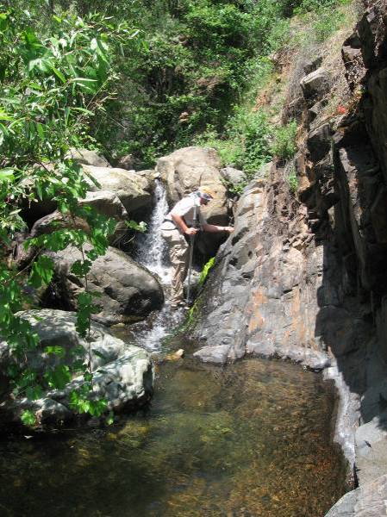
Other aquatic habitat characteristics, species observations, drawings, or comments:

Not suitable for CRLF. Steep gradient, bedrock/boulder. No backwater or escape cover. No roots or vegetation for egg attachment. Dries up in summer, so cannot complete life cycle.

California Red-Legged Frog Habitat Site Assessment Data Sheet

Site Assessment reviewed by:
(FWS Field Office) |  |  |  |  | (Date) |  |  |  |  | (Biologist)
Date of Site Assessment: |  |  |  |  | 6/27/2007
 |  |  |  |  | (mm/dd/yyyy)
Site Assessment Biologists |  |  |  |  | Graf, Peter |  |  |  |  | VanDellen, Chet
 |  |  |  |  | (Last name) |  |  | (First Name) |  | (Last name) |  |  | (First Name)
 |  |  |  |  | (Last name) |  |  | (First Name) |  | (Last name) |  |  | (First Name)
Site Location: |  |  | Placer County, Canyon Creek, 10S 681773, 4313650
 |  |  | (County, general location name, GPS coordinates)
**ATTACH A MAP (include habitat types, important features, and species location)**
Proposed project name: |  |  |  | Placer County Water Agency – Middle Fork American River Project
Brief description of proposed action:

PCWA owns and operates the MFP, a multi-purpose water supply and hydroelectric project designed to control and conserve waters of the Middle Fork American River, the and Rubicon River, and several associated tributary streams. The MFP system consists of two major storage reservoirs, five smaller regulating reservoirs and diversion pools, and five powerhouses and supplies water for homes, industry, and agriculture within western Placer County. PCWA operates the MFP under the terms of the FERC License No. 2079. The current license will expire on February 28, 2013, and PCWA will be seeking a new license for the MFP pursuant to the FERC’s ILP regulations.

1) Is this site within the current or historic range of the CRF (circle one) |  |  |  |  |  |  |  |  |  |  |  |  | Yes | No
2) Are there known records of CRF within 1.6 km (1 mi) of the site (circle one) |  |  |  |  |  |  |  |  |  |  |  |  | Yes | No
If yes, attach a list of all known CRF records with a map showing all locations.

GENERAL AQUATIC HABITAT CHARACTERIZATION

(If multiple ponds or streams are within the proposed action area, fill out one data sheet for each)

POND HABITAT:

Size: |  |  |  |  |  |  | Maximum depth:
Vegetation: emergent, overhanging, dominant species:
Substrate:
Perennial or Ephemeral (circle one) |  |  |  |  |  | If ephemeral, date it goes dry:

STREAM HABITAT:

Width (bank full): |  |  |  | ~ 35 feet
Depth (bank full): |  |  |  | 3 feet
Stream gradient (percent slope): |  |  |  |  |  | 5%
Are there pools (circle one): |  |  |  | Yes |  |  | No
 | If yes,
 | Size of stream pools: |  |  |  | 15 to 35 feet in length
 | Maximum depth of stream pools: |  |  |  |  |  |  |  | 2.5 feet
Characterize non-pool habitat: run, riffle, glide, other: |  |  |  |  |  |  |  |  |  |  | Non-pool habitats includes bedrock
chutes and cascades
Vegetation: emergent, overhanging, dominant species: |  |  |  |  |  |  |  |  |  | Medium to small-sized alder and wil-
low trees and shrubs were established within the channel, while oaks provided most of the
overstory canopy. Canopy cover along the stream margins was typically high, although several
open, bedrock areas (with no vegetation) occurred. No emergent or aquatic vegetation present.
Substrate: |  | Bedrock, boulder, and cobble
Bank description: |  |  | Stream is steep, confined, and bedrock-dominated. Banks are steep and
rocky, not vegetated.
Perennial or Ephemeral (circle one) |  |  |  |  |  |  |  | If ephemeral, date it goes dry:
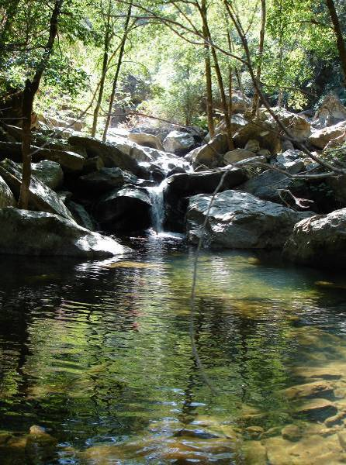
Other aquatic habitat characteristics, species observations, drawings, or comments:

No bullfrogs or other non-native predators observed.

California Red-Legged Frog Habitat Site Assessment Data Sheet

Site Assessment reviewed by:
(FWS Field Office) |  |  |  |  | (Date) |  |  |  |  | (Biologist)
Date of Site Assessment: |  |  |  |  | 5/21/2007, 6/6/2007, and 8/22/2007
 |  |  |  |  | (mm/dd/yyyy)
Site Assessment Biologists |  |  |  |  | VanDellen, Chet |  |  |  |  | Gonsolin, Earl
 |  |  |  |  | (Last name) |  |  | (First Name) |  | (Last name) |  |  | (First Name)
 |  |  |  |  | (Last name) |  |  | (First Name) |  | (Last name) |  |  | (First Name)
Site Location: |  |  | El Dorado, Otter Creek, 10S 0686476, 4314265
 |  |  | (County, general location name, GPS coordinates)
**ATTACH A MAP (include habitat types, important features, and species location)**
Proposed project name: |  |  |  | Placer County Water Agency – Middle Fork American River Project
Brief description of proposed action:

PCWA owns and operates the MFP, a multi-purpose water supply and hydroelectric project designed to control and conserve waters of the Middle Fork American River, the and Rubicon River, and several associated tributary streams. The MFP system consists of two major storage reservoirs, five smaller regulating reservoirs and diversion pools, and five powerhouses and supplies water for homes, industry, and agriculture within western Placer County. PCWA operates the MFP under the terms of the FERC License No. 2079. The current license will expire on February 28, 2013, and PCWA will be seeking a new license for the MFP pursuant to the FERC’s ILP regulations.

1) Is this site within the current or historic range of the CRF (circle one) |  |  |  |  |  |  |  |  |  |  |  |  | Yes | No
2) Are there known records of CRF within 1.6 km (1 mi) of the site (circle one) |  |  |  |  |  |  |  |  |  |  |  |  | Yes | No
If yes, attach a list of all known CRF records with a map showing all locations.

GENERAL AQUATIC HABITAT CHARACTERIZATION

(If multiple ponds or streams are within the proposed action area, fill out one data sheet for each)

POND HABITAT:

Size: |  |  |  |  |  |  | Maximum depth:
Vegetation: emergent, overhanging, dominant species:
Substrate:
Perennial or Ephemeral (circle one) |  |  |  |  |  | If ephemeral, date it goes dry:

STREAM HABITAT:

Width (bank full): |  |  |  | 10 ft (32 ft)
Depth (bank full): |  |  |  | 1.5 ft
Stream gradient (percent slope): |  |  |  |  |  | 1.5%
Are there pools (circle one): |  |  |  | Yes |  |  | No
 | If yes,
 | Size of stream pools: |  |  |  | 15 to 40 feet in length
 | Maximum depth of stream pools: |  |  |  |  |  |  |  | 3 feet
Characterize non-pool habitat: run, riffle, glide, other: |  |  |  |  |  |  |  |  |  |  | riffles, runs, & cascades
Vegetation: emergent, overhanging, dominant species: |  |  |  |  |  |  |  |  |  | No floating or emergent vegetation.
Riparian vegetation was dominated by large to medium-size Salix sp., Populus fremontii, and
Alnus sp. along bank. Canopy cover along stream was greater than 50%.
Substrate: |  | boulder/bedrock and cobble
Bank description: |  |  | floodplain typically along at least one bank
Perennial or Ephemeral (circle one) |  |  |  |  |  |  |  | If ephemeral, date it goes dry:
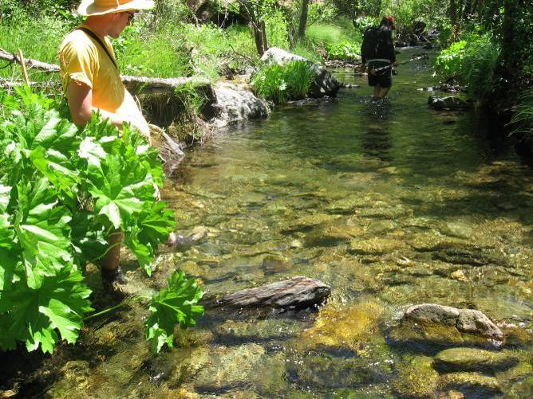
Other aquatic habitat characteristics, species observations, drawings, or comments:

No CRLF detected. Not suitable breeding habitat for CRLF. No attachment substrate for eggs, little escape cover. No backwater pools or secondary channels. During August flows were less than 1 cfs. Crayfish and other non-native species observed.

California Red-Legged Frog Habitat Site Assessment Data Sheet

Site Assessment reviewed by:
(FWS Field Office) |  |  |  |  | (Date) |  |  |  |  | (Biologist)
Date of Site Assessment: |  |  |  |  | 10/15/2007
 |  |  |  |  | (mm/dd/yyyy)
Site Assessment Biologists |  |  |  |  | Addley, Craig
 |  |  |  |  | (Last name) |  |  | (First Name) |  | (Last name) |  |  | (First Name)
 |  |  |  |  | (Last name) |  |  | (First Name) |  | (Last name) |  |  | (First Name)
Site Location: |  |  | El Dorado, Jesse Canyon Creek Confluence, 10S 687906 4316268
 |  |  | (County, general location name, GPS coordinates)
**ATTACH A MAP (include habitat types, important features, and species location)**
Proposed project name: |  |  |  | Placer County Water Agency – Middle Fork American River Project
Brief description of proposed action:

PCWA owns and operates the MFP, a multi-purpose water supply and hydroelectric project designed to control and conserve waters of the Middle Fork American River, the and Rubicon River, and several associated tributary streams. The MFP system consists of two major storage reservoirs, five smaller regulating reservoirs and diversion pools, and five powerhouses and supplies water for homes, industry, and agriculture within western Placer County. PCWA operates the MFP under the terms of the FERC License No. 2079. The current license will expire on February 28, 2013, and PCWA will be seeking a new license for the MFP pursuant to the FERC’s ILP regulations.

1) Is this site within the current or historic range of the CRF (circle one) |  |  |  |  |  |  |  |  |  |  |  |  | Yes | No
2) Are there known records of CRF within 1.6 km (1 mi) of the site (circle one) |  |  |  |  |  |  |  |  |  |  |  |  | Yes | No
If yes, attach a list of all known CRF records with a map showing all locations.

GENERAL AQUATIC HABITAT CHARACTERIZATION

(If multiple ponds or streams are within the proposed action area, fill out one data sheet for each)

POND HABITAT:

Size: |  |  |  |  |  |  | Maximum depth:
Vegetation: emergent, overhanging, dominant species:
Substrate:
Perennial or Ephemeral (circle one) |  |  |  |  |  | If ephemeral, date it goes dry:

STREAM HABITAT:

Width (bank full): |  |  |  | 10 ft
Depth (bank full): |  |  |  | < 1 ft
Stream gradient (percent slope): |  |  |  |  |  | Steep (~7%)
Are there pools (circle one): |  |  |  | Yes |  |  | No
 | If yes,
 | Size of stream pools: |  |  |  | 15 to 20 feet in length
 | Maximum depth of stream pools: |  |  |  |  |  |  |  | 3 ft
Characterize non-pool habitat: run, riffle, glide, other: |  |  |  |  |  |  |  |  |  |  | waterfalls and chutes
Vegetation: emergent, overhanging, dominant species:
Alnus sp. and Rubus discolor.
Substrate: |  | bedrock & boulder
Bank description: |  |  | steep, narrow canyon: bedrock-confined, narrow stream bed with
no backwater or secondary channels
Perennial or Ephemeral (circle one) |  |  |  |  |  |  |  | If ephemeral, date it goes dry:
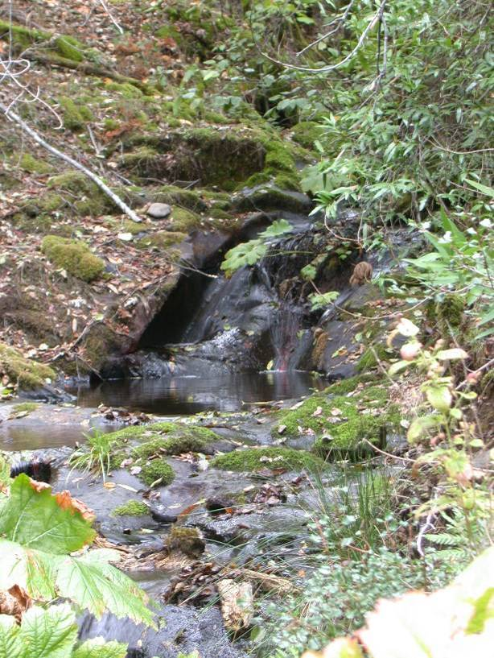
Other aquatic habitat characteristics, species observations, drawings, or comments:

No amphibians observed. Not suitable for CRLF. Very high gradient, bedrock confined, & narrow. No backwater or secondary channels. No escape cover. No roots or vegetation for egg attachment.

California Red-Legged Frog Habitat Site Assessment Data Sheet

Site Assessment reviewed by:
(FWS Field Office) |  |  |  |  | (Date) |  |  |  |  | (Biologist)
Date of Site Assessment: |  |  |  |  | 10/15/2007
 |  |  |  |  | (mm/dd/yyyy)
Site Assessment Biologists |  |  |  |  | Addley, Craig
 |  |  |  |  | (Last name) |  |  | (First Name) |  | (Last name) |  |  | (First Name)
 |  |  |  |  | (Last name) |  |  | (First Name) |  | (Last name) |  |  | (First Name)
Site Location: |  |  | Placer, Pond Creek Confluence, 10S 687945 4317961 (NAD 83)
 |  |  | (County, general location name, GPS coordinates)
**ATTACH A MAP (include habitat types, important features, and species location)**
Proposed project name: |  |  |  | Placer County Water Agency – Middle Fork American River Project
Brief description of proposed action:

PCWA owns and operates the MFP, a multi-purpose water supply and hydroelectric project designed to control and conserve waters of the Middle Fork American River, the and Rubicon River, and several associated tributary streams. The MFP system consists of two major storage reservoirs, five smaller regulating reservoirs and diversion pools, and five powerhouses and supplies water for homes, industry, and agriculture within western Placer County. PCWA operates the MFP under the terms of the FERC License No. 2079. The current license will expire on February 28, 2013, and PCWA will be seeking a new license for the MFP pursuant to the FERC’s ILP regulations.

1) Is this site within the current or historic range of the CRF (circle one) |  |  |  |  |  |  |  |  |  |  |  |  | Yes | No
2) Are there known records of CRF within 1.6 km (1 mi) of the site (circle one) |  |  |  |  |  |  |  |  |  |  |  |  | Yes | No
If yes, attach a list of all known CRF records with a map showing all locations.

GENERAL AQUATIC HABITAT CHARACTERIZATION

(If multiple ponds or streams are within the proposed action area, fill out one data sheet for each)

POND HABITAT:

Size: |  |  |  |  |  |  | Maximum depth:
Vegetation: emergent, overhanging, dominant species:
Substrate:
Perennial or Ephemeral (circle one) |  |  |  |  |  | If ephemeral, date it goes dry:

STREAM HABITAT:

Width (bank full): |  |  |  | 10 ft
Depth (bank full): |  |  |  | .5 to 1.5 feet
Stream gradient (percent slope): |  |  |  |  |  | Steep (~7 %)
Are there pools (circle one): |  |  |  | Yes |  |  | No
 | If yes,
 | Size of stream pools: |  |  |  | 15 to 20 feet in length
 | Maximum depth of stream pools: |  |  |  |  |  |  |  | 3 ft
Characterize non-pool habitat: run, riffle, glide, other: |  |  |  |  |  |  |  |  |  |  | waterfalls and chutes
Vegetation: emergent, overhanging, dominant species: |  |  |  |  |  |  |  |  |  | No emergent or floating vegetation.
Salix sp. and Alnus sp. and shrubs along banks.
Substrate: |  | boulder/bedrock
Bank description: |  |  | steep, narrow canyon
Perennial or Ephemeral (circle one) |  |  |  |  |  |  |  | If ephemeral, date it goes dry:
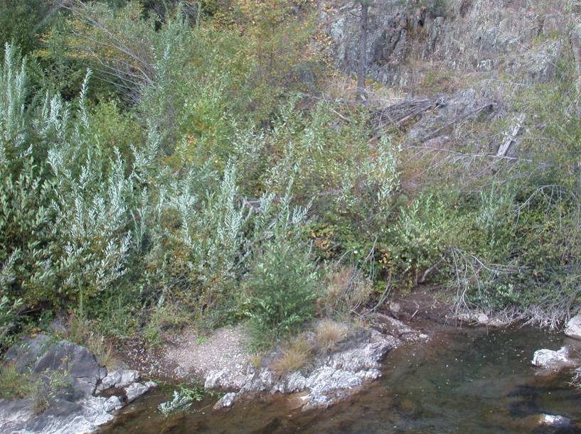
Other aquatic habitat characteristics, species observations, drawings, or comments:

No amphibians observed. Not suitable for CRLF at any life stage. Very high gradient, bedrock confined, & narrow. No backwater or secondary channels. No escape cover. No roots or vegetation for egg attachment.

California Red-Legged Frog Habitat Site Assessment Data Sheet

Site Assessment reviewed by:
(FWS Field Office) |  |  |  |  | (Date) |  |  |  |  | (Biologist)
Date of Site Assessment: |  |  |  |  | 5/24/2007, 6/11/2007, and 8/30/2007
 |  |  |  |  | (mm/dd/yyyy)
Site Assessment Biologists |  |  |  |  | VanDellen, Chet |  |  |  |  | Gonsolin, Earl
 |  |  |  |  | (Last name) |  |  | (First Name) |  | (Last name) |  |  | (First Name)
 |  |  |  |  | Buck, Christina
 |  |  |  |  | (Last name) |  |  | (First Name) |  | (Last name) |  |  | (First Name)
Site Location: |  |  | Placer County, Volcano Creek, 10S 691520, 4319082
 |  |  | (County, general location name, GPS coordinates)
**ATTACH A MAP (include habitat types, important features, and species location)**
Proposed project name: |  |  |  | Placer County Water Agency – Middle Fork American River Project
Brief description of proposed action:

PCWA owns and operates the MFP, a multi-purpose water supply and hydroelectric project designed to control and conserve waters of the Middle Fork American River, the and Rubicon River, and several associated tributary streams. The MFP system consists of two major storage reservoirs, five smaller regulating reservoirs and diversion pools, and five powerhouses and supplies water for homes, industry, and agriculture within western Placer County. PCWA operates the MFP under the terms of the FERC License No. 2079. The current license will expire on February 28, 2013, and PCWA will be seeking a new license for the MFP pursuant to the FERC’s ILP regulations.

1) Is this site within the current or historic range of the CRF (circle one) |  |  |  |  |  |  |  |  |  |  |  |  | Yes | No
2) Are there known records of CRF within 1.6 km (1 mi) of the site (circle one) |  |  |  |  |  |  |  |  |  |  |  |  | Yes | No
If yes, attach a list of all known CRF records with a map showing all locations.

GENERAL AQUATIC HABITAT CHARACTERIZATION

(If multiple ponds or streams are within the proposed action area, fill out one data sheet for each)

POND HABITAT:

Size: |  |  |  |  |  |  | Maximum depth:
Vegetation: emergent, overhanging, dominant species:
Substrate:
Perennial or Ephemeral (circle one) |  |  |  |  |  | If ephemeral, date it goes dry:

STREAM HABITAT:

Width (bank full): |  |  |  | 15 feet
Depth (bank full): |  |  |  | .5 to 1.5 feet
Stream gradient (percent slope): |  |  |  |  |  | ~ 7%
Are there pools (circle one): |  |  |  | Yes |  |  | No
 | If yes,
 | Size of stream pools: |  |  |  | 15 to 20 feet in length
 | Maximum depth of stream pools: |  |  |  |  |  |  |  | 3 feet
Characterize non-pool habitat: run, riffle, glide, other: |  |  |  |  |  |  |  |  |  |  | Non-pool habitats included cascades
and step-pools
Vegetation: emergent, overhanging, dominant species: |  |  |  |  |  |  |  |  |  | No emergent or aquatic vegetation.
Small to medium-sized alder and willow trees and shrubs present in and along channel.
Canopy cover along stream margins generally high, with sections of open bedrock.
Substrate: |  | Dominated by bedrock and boulders
Bank description: |  |  | Stream banks composed of rocks and boulders, some bedrock. Clumps
of vegetation including Carex spp., and Indian rhubarb along banks.
Perennial or Ephemeral (circle one) |  |  |  |  |  |  |  | If ephemeral, date it goes dry:
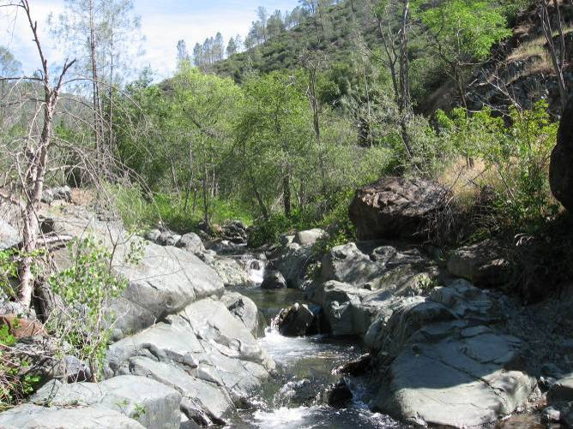
Other aquatic habitat characteristics, species observations, drawings, or comments:

Small perennial creek flowing within steep canyon walls. Flows during field surveys were less than 1 cfs. Non-native aquatic predators not observed.

California Red-Legged Frog Habitat Site Assessment Data Sheet

Site Assessment reviewed by:
(FWS Field Office) |  |  |  |  | (Date) |  |  |  |  | (Biologist)
Date of Site Assessment: |  |  |  |  | 8/29/2007
 |  |  |  |  | (mm/dd/yyyy)
Site Assessment Biologists |  |  |  |  | Gonsolin, Earl |  |  |  |  | VanDellen, Chet
 |  |  |  |  | (Last name) |  |  | (First Name) |  | (Last name) |  |  | (First Name)
 |  |  |  |  | Buck, Christina
 |  |  |  |  | (Last name) |  |  | (First Name) |  | (Last name) |  |  | (First Name)
Site Location: |  |  | Placer County, Brushy Canyon Creek, 10S 701685, 4314562
 |  |  | (County, general location name, GPS coordinates)
**ATTACH A MAP (include habitat types, important features, and species location)**
Proposed project name: |  |  |  | Placer County Water Agency – Middle Fork American River Project
Brief description of proposed action:

PCWA owns and operates the MFP, a multi-purpose water supply and hydroelectric project designed to control and conserve waters of the Middle Fork American River, the and Rubicon River, and several associated tributary streams. The MFP system consists of two major storage reservoirs, five smaller regulating reservoirs and diversion pools, and five powerhouses and supplies water for homes, industry, and agriculture within western Placer County. PCWA operates the MFP under the terms of the FERC License No. 2079. The current license will expire on February 28, 2013, and PCWA will be seeking a new license for the MFP pursuant to the FERC’s ILP regulations.

1) Is this site within the current or historic range of the CRF (circle one) |  |  |  |  |  |  |  |  |  |  |  |  | Yes | No
2) Are there known records of CRF within 1.6 km (1 mi) of the site (circle one) |  |  |  |  |  |  |  |  |  |  |  |  | Yes | No
If yes, attach a list of all known CRF records with a map showing all locations.

GENERAL AQUATIC HABITAT CHARACTERIZATION

(If multiple ponds or streams are within the proposed action area, fill out one data sheet for each)

POND HABITAT:

Size: |  |  |  |  |  |  | Maximum depth:
Vegetation: emergent, overhanging, dominant species:
Substrate:
Perennial or Ephemeral (circle one) |  |  |  |  |  | If ephemeral, date it goes dry:

STREAM HABITAT:

Width (bank full): |  |  |  | 15 feet
Depth (bank full): |  |  |  | .5 to 1.5 feet
Stream gradient (percent slope): |  |  |  |  |  | 5%
Are there pools (circle one): |  |  |  | Yes |  |  | No
 | If yes,
 | Size of stream pools: |  |  |  | 20 to 45 feet long
 | Maximum depth of stream pools: |  |  |  |  |  |  |  | 3 feet
Characterize non-pool habitat: run, riffle, glide, other: |  |  |  |  |  |  |  |  |  |  | High gradient cascades
Vegetation: emergent, overhanging, dominant species: |  |  |  |  |  |  |  |  |  | No emergent or aquatic vegetation.
A oak overstory shades the channel
Substrate: |  | Bedrock and boulders
Bank description: |  |  | Set within a steep river canyon, channel is confined to bedrock
Perennial or Ephemeral (circle one) |  |  |  |  |  |  |  | If ephemeral, date it goes dry:
Other aquatic habitat characteristics, species observations, drawings, or comments:
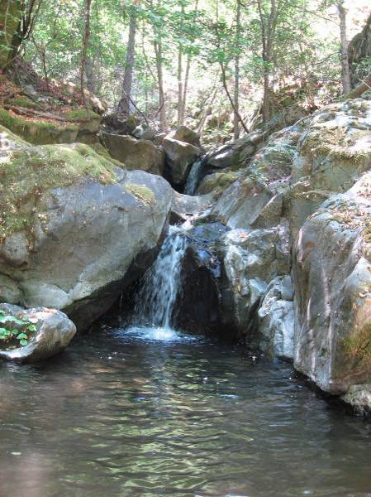

California Red-Legged Frog Habitat Site Assessment Data Sheet

Site Assessment reviewed by:
(FWS Field Office) |  |  |  |  | (Date) |  |  |  |  | (Biologist)
Date of Site Assessment: |  |  |  |  | 8/28/2007
 |  |  |  |  | (mm/dd/yyyy)
Site Assessment Biologists |  |  |  |  | Buck, Christina |  |  |  |  | Gonsolin, Earl
 |  |  |  |  | (Last name) |  |  | (First Name) |  | (Last name) |  |  | (First Name)
 |  |  |  |  | VanDellen, Chet
 |  |  |  |  | (Last name) |  |  | (First Name) |  | (Last name) |  |  | (First Name)
Site Location: |  |  | Placer County, Pilot Creek, 10S 700716, 4316067
 |  |  | (County, general location name, GPS coordinates)
**ATTACH A MAP (include habitat types, important features, and species location)**
Proposed project name: |  |  |  | Placer County Water Agency – Middle Fork American River Project
Brief description of proposed action:

PCWA owns and operates the MFP, a multi-purpose water supply and hydroelectric project designed to control and conserve waters of the Middle Fork American River, the and Rubicon River, and several associated tributary streams. The MFP system consists of two major storage reservoirs, five smaller regulating reservoirs and diversion pools, and five powerhouses and supplies water for homes, industry, and agriculture within western Placer County. PCWA operates the MFP under the terms of the FERC License No. 2079. The current license will expire on February 28, 2013, and PCWA will be seeking a new license for the MFP pursuant to the FERC’s ILP regulations.

1) Is this site within the current or historic range of the CRF (circle one) |  |  |  |  |  |  |  |  |  |  |  |  | Yes | No
2) Are there known records of CRF within 1.6 km (1 mi) of the site (circle one) |  |  |  |  |  |  |  |  |  |  |  |  | Yes | No
If yes, attach a list of all known CRF records with a map showing all locations.

GENERAL AQUATIC HABITAT CHARACTERIZATION

(If multiple ponds or streams are within the proposed action area, fill out one data sheet for each)

POND HABITAT:

Size: |  |  |  |  |  |  | Maximum depth:
Vegetation: emergent, overhanging, dominant species:
Substrate:
Perennial or Ephemeral (circle one) |  |  |  |  |  | If ephemeral, date it goes dry:

STREAM HABITAT:

Width (bank full): |  |  |  | ~ 15 feet
Depth (bank full): |  |  |  | ~ 1 foot
Stream gradient (percent slope): |  |  |  |  |  | 5%
Are there pools (circle one): |  |  |  | Yes |  |  | No
 | If yes,
 | Size of stream pools: |  |  |  | 25 to 40 feet in length
 | Maximum depth of stream pools: |  |  |  |  |  |  |  | 15 feet
Characterize non-pool habitat: run, riffle, glide, other: |  |  |  |  |  |  |  |  |  |  | Instream habitats primarily high-
gradient cascades and plunge-pools, although several lower-gradient sections with riffles
occurred.
Vegetation: emergent, overhanging, dominant species: |  |  |  |  |  |  |  |  |  | No emergent or aquatic vegetation.
Riparian vegetation dominated by small to medium willow and alder trees, with moderate
canopy coverage along the stream margins.
Substrate:
Bank description:
Perennial or Ephemeral (circle one) |  |  |  |  |  |  |  | If ephemeral, date it goes dry:
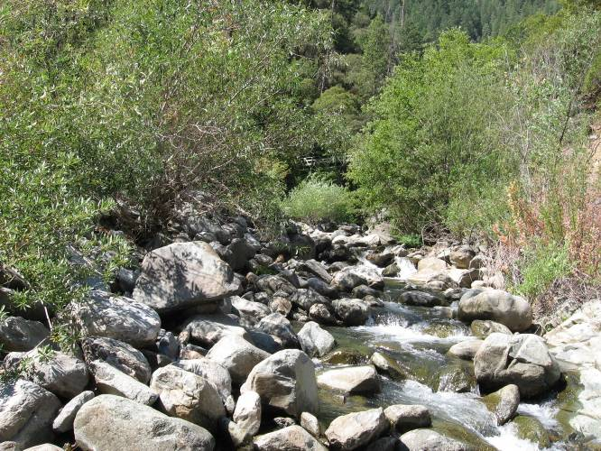
Other aquatic habitat characteristics, species observations, drawings, or comments:

Pilot Creek is a narrow (approx. 4.5 m) perennial stream confined within steep bedrock canyon walls. Flow is regulated by SMUD at Stumpy Meadows reservoir. Flows at the time of the survey were less than 2 cfs. Non-native predatory species not observed.

California Red-Legged Frog Habitat Site Assessment Data Sheet

Site Assessment reviewed by:
(FWS Field Office) |  |  |  |  | (Date) |  |  |  |  | (Biologist)
Date of Site Assessment: |  |  |  |  | 8/30/2007
 |  |  |  |  | (mm/dd/yyyy)
Site Assessment Biologists |  |  |  |  | VanDellen, Chet |  |  |  |  | Buck, Christina
 |  |  |  |  | (Last name) |  |  | (First Name) |  | (Last name) |  |  | (First Name)
 |  |  |  |  | (Last name) |  |  | (First Name) |  | (Last name) |  |  | (First Name)
Site Location: |  |  | Placer County, Wallace Canyon Creek, 10S 707906, 4317361
 |  |  | (County, general location name, GPS coordinates)
**ATTACH A MAP (include habitat types, important features, and species location)**
Proposed project name: |  |  |  | Placer County Water Agency – Middle Fork American River Project
Brief description of proposed action:

PCWA owns and operates the MFP, a multi-purpose water supply and hydroelectric project designed to control and conserve waters of the Middle Fork American River, the and Rubicon River, and several associated tributary streams. The MFP system consists of two major storage reservoirs, five smaller regulating reservoirs and diversion pools, and five powerhouses and supplies water for homes, industry, and agriculture within western Placer County. PCWA operates the MFP under the terms of the FERC License No. 2079. The current license will expire on February 28, 2013, and PCWA will be seeking a new license for the MFP pursuant to the FERC’s ILP regulations.

1) Is this site within the current or historic range of the CRF (circle one) |  |  |  |  |  |  |  |  |  |  |  |  | Yes | No
2) Are there known records of CRF within 1.6 km (1 mi) of the site (circle one) |  |  |  |  |  |  |  |  |  |  |  |  | Yes | No
If yes, attach a list of all known CRF records with a map showing all locations.

GENERAL AQUATIC HABITAT CHARACTERIZATION

(If multiple ponds or streams are within the proposed action area, fill out one data sheet for each)

POND HABITAT:

Size: |  |  |  |  |  |  | Maximum depth:
Vegetation: emergent, overhanging, dominant species:
Substrate:
Perennial or Ephemeral (circle one) |  |  |  |  |  | If ephemeral, date it goes dry:

STREAM HABITAT:

Width (bank full): |  |  |  | 20 feet
Depth (bank full): |  |  |  | 3 feet
Stream gradient (percent slope): |  |  |  |  |  | 7%
Are there pools (circle one): |  |  |  | Yes |  |  | No
 | If yes,
 | Size of stream pools: |  |  |  | 20 to 25 feet in length
 | Maximum depth of stream pools: |  |  |  |  |  |  |  | 5 feet
Characterize non-pool habitat: run, riffle, glide, other: |  |  |  |  |  |  |  |  |  |  | High-gradient channel dominated
by large boulders and bedrock, waterfalls and chutes
Vegetation: emergent, overhanging, dominant species: |  |  |  |  |  |  |  |  |  | No emergent or aquatic vegetation.
Small to medium-sized alder and willow trees and shrubs were present in the channel, with oaks
providing the overstory. Canopy cover typically high.
Substrate: |  | Bedrock and boulder
Bank description: |  |  | River runs through a steep canyon, no flood plain.
Perennial or Ephemeral (circle one) |  |  |  |  |  |  |  | If ephemeral, date it goes dry:
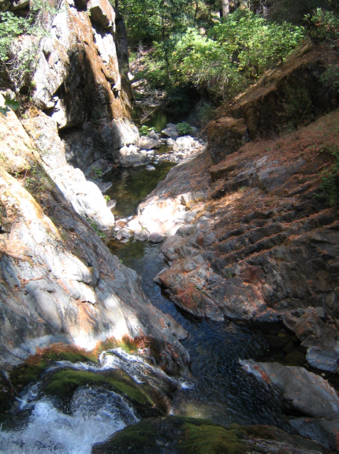
Other aquatic habitat characteristics, species observations, drawings, or comments:

California Red-Legged Frog Habitat Site Assessment Data Sheet

Site Assessment reviewed by:
(FWS Field Office) |  |  |  |  | (Date) |  |  |  |  | (Biologist)
Date of Site Assessment: |  |  |  |  | 8/24/2007
 |  |  |  |  | (mm/dd/yyyy)
Site Assessment Biologists |  |  |  |  | Graf, Peter |  |  |  |  | VanDellen, Chet
 |  |  |  |  | (Last name) |  |  | (First Name) |  | (Last name) |  |  | (First Name)
 |  |  |  |  | (Last name) |  |  | (First Name) |  | (Last name) |  |  | (First Name)
Site Location: |  |  | Placer County, Long Canyon Creek, 10S, 700305, 4318232
 |  |  | (County, general location name, GPS coordinates)
**ATTACH A MAP (include habitat types, important features, and species location)**
Proposed project name: |  |  |  | Placer County Water Agency – Middle Fork American River Project
Brief description of proposed action:

PCWA owns and operates the MFP, a multi-purpose water supply and hydroelectric project designed to control and conserve waters of the Middle Fork American River, the and Rubicon River, and several associated tributary streams. The MFP system consists of two major storage reservoirs, five smaller regulating reservoirs and diversion pools, and five powerhouses and supplies water for homes, industry, and agriculture within western Placer County. PCWA operates the MFP under the terms of the FERC License No. 2079. The current license will expire on February 28, 2013, and PCWA will be seeking a new license for the MFP pursuant to the FERC’s ILP regulations.

1) Is this site within the current or historic range of the CRF (circle one) |  |  |  |  |  |  |  |  |  |  |  |  | Yes | No
2) Are there known records of CRF within 1.6 km (1 mi) of the site (circle one) |  |  |  |  |  |  |  |  |  |  |  |  | Yes | No
If yes, attach a list of all known CRF records with a map showing all locations.

GENERAL AQUATIC HABITAT CHARACTERIZATION

(If multiple ponds or streams are within the proposed action area, fill out one data sheet for each)

POND HABITAT:

Size: |  |  |  |  |  |  | Maximum depth:
Vegetation: emergent, overhanging, dominant species:
Substrate:
Perennial or Ephemeral (circle one) |  |  |  |  |  | If ephemeral, date it goes dry:

STREAM HABITAT:

Width (bank full): |  |  |  | 35 to 80 feet
Depth (bank full): |  |  |  | 1.4 to 3.5 feet
Stream gradient (percent slope): |  |  |  |  |  | 2 to 4%
Are there pools (circle one): |  |  |  | Yes |  |  | No
 | If yes,
 | Size of stream pools: |  |  |  | 10 to 220 feet long
 | Maximum depth of stream pools: |  |  |  |  |  |  |  | 6 feet
Characterize non-pool habitat: run, riffle, glide, other: |  |  |  |  |  |  |  |  |  |  | High gradient riffles, cascades, and
plunge pools
Vegetation: emergent, overhanging, dominant species: |  |  |  |  |  |  |  |  |  | No emergent or floating vegetation
riparian vegetation includes small to medium-sized willows and alder shrubs and trees, with
Canopy cover typically less than 50%
Substrate: |  | Boulder and bedrock, some cobble
Bank description: |  |  | Stream is confined within steep canyon walls
Perennial or Ephemeral (circle one) |  |  |  |  |  |  |  | If ephemeral, date it goes dry:
Other aquatic habitat characteristics, species observations, drawings, or comments:

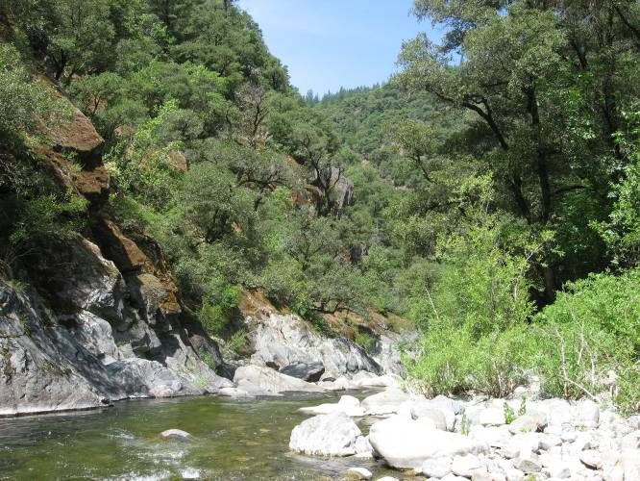

California Red-Legged Frog Habitat Site Assessment Data Sheet

Site Assessment reviewed by:
(FWS Field Office) |  |  |  |  | (Date) |  |  |  |  | (Biologist)
Date of Site Assessment: |  |  |  |  | 5/31/2007
 |  |  |  |  | (mm/dd/yyyy)
Site Assessment Biologists |  |  |  |  | Graf, Peter |  |  |  |  | Friermuth, Brian
 |  |  |  |  | (Last name) |  |  | (First Name) |  | (Last name) |  |  | (First Name)
 |  |  |  |  | (Last name) |  |  | (First Name) |  | (Last name) |  |  | (First Name)
Site Location: |  |  | Placer County, North Fork Long Canyon Creek, 10 S 715087, 4322045
 |  |  | (County, general location name, GPS coordinates)
**ATTACH A MAP (include habitat types, important features, and species location)**
Proposed project name: |  |  |  | Placer County Water Agency – Middle Fork American River Project
Brief description of proposed action:

PCWA owns and operates the MFP, a multi-purpose water supply and hydroelectric project designed to control and conserve waters of the Middle Fork American River, the and Rubicon River, and several associated tributary streams. The MFP system consists of two major storage reservoirs, five smaller regulating reservoirs and diversion pools, and five powerhouses and supplies water for homes, industry, and agriculture within western Placer County. PCWA operates the MFP under the terms of the FERC License No. 2079. The current license will expire on February 28, 2013, and PCWA will be seeking a new license for the MFP pursuant to the FERC’s ILP regulations.

1) Is this site within the current or historic range of the CRF (circle one) |  |  |  |  |  |  |  |  |  |  |  |  | Yes | No
2) Are there known records of CRF within 1.6 km (1 mi) of the site (circle one) |  |  |  |  |  |  |  |  |  |  |  |  | Yes | No
If yes, attach a list of all known CRF records with a map showing all locations.

GENERAL AQUATIC HABITAT CHARACTERIZATION

(If multiple ponds or streams are within the proposed action area, fill out one data sheet for each)

POND HABITAT:

Size: |  |  |  |  |  |  | Maximum depth:
Vegetation: emergent, overhanging, dominant species:
Substrate:
Perennial or Ephemeral (circle one) |  |  |  |  |  | If ephemeral, date it goes dry:

STREAM HABITAT:

Width (bank full): |  |  |  | 26 to 40 feet
Depth (bank full): |  |  |  | ~1 to 1.5 feet
Stream gradient (percent slope): |  |  |  |  |  | > 2%
Are there pools (circle one): |  |  |  | Yes |  |  | No
 | If yes,
 | Size of stream pools: |  |  |  | 10 to 220 feet long
 | Maximum depth of stream pools: |  |  |  |  |  |  |  | 2 feet
Characterize non-pool habitat: run, riffle, glide, other: |  |  |  |  |  |  |  |  |  |  | High-gradient riffles, cascades,
and plunge pools
Vegetation: emergent, overhanging, dominant species: |  |  |  |  |  |  |  |  |  | No emergent or floating vegetation.
Riparian cover typically greater than 50%, dominated by alders and willows. Firs and pines
contribute to overstory in some areas.
Substrate: |  | Boulder and cobble, some bedrock
Bank description: |  |  | River runs through a pine forest habitat. Stream banks composed of
rocks and boulders, some bedrock. Some clumps of vegetation (i.e., Carex spp. and Indian
Rhubarb) along banks.
Perennial or Ephemeral (circle one) |  |  |  |  |  |  |  | If ephemeral, date it goes dry:
Other aquatic habitat characteristics, species observations, drawings, or comments:

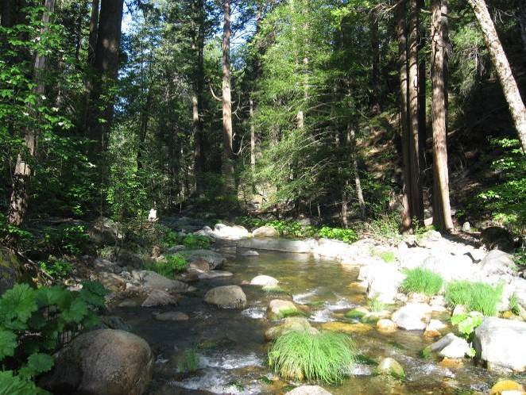
No bullfrogs or other predators observed.

California Red-Legged Frog Habitat Site Assessment Data Sheet

Site Assessment reviewed by:
(FWS Field Office) |  |  |  |  | (Date) |  |  |  |  | (Biologist)
Date of Site Assessment: |  |  |  |  | 5/31/2007
 |  |  |  |  | (mm/dd/yyyy)
Site Assessment Biologists |  |  |  |  | Graf, Peter |  |  |  |  | Friermuth, Brian
 |  |  |  |  | (Last name) |  |  | (First Name) |  | (Last name) |  |  | (First Name)
 |  |  |  |  | (Last name) |  |  | (First Name) |  | (Last name) |  |  | (First Name)
Site Location: |  |  | Placer County, South Fork Long Canyon Creek, 10S, 714667, 4321687
 |  |  | (County, general location name, GPS coordinates)
**ATTACH A MAP (include habitat types, important features, and species location)**
Proposed project name: |  |  |  | Placer County Water Agency – Middle Fork American River Project
Brief description of proposed action:

PCWA owns and operates the MFP, a multi-purpose water supply and hydroelectric project designed to control and conserve waters of the Middle Fork American River, the and Rubicon River, and several associated tributary streams. The MFP system consists of two major storage reservoirs, five smaller regulating reservoirs and diversion pools, and five powerhouses and supplies water for homes, industry, and agriculture within western Placer County. PCWA operates the MFP under the terms of the FERC License No. 2079. The current license will expire on February 28, 2013, and PCWA will be seeking a new license for the MFP pursuant to the FERC’s ILP regulations.

1) Is this site within the current or historic range of the CRF (circle one) |  |  |  |  |  |  |  |  |  |  |  |  | Yes | No
2) Are there known records of CRF within 1.6 km (1 mi) of the site (circle one) |  |  |  |  |  |  |  |  |  |  |  |  | Yes | No
If yes, attach a list of all known CRF records with a map showing all locations.

GENERAL AQUATIC HABITAT CHARACTERIZATION

(If multiple ponds or streams are within the proposed action area, fill out one data sheet for each)

POND HABITAT:

Size: |  |  |  |  |  |  | Maximum depth:
Vegetation: emergent, overhanging, dominant species:
Substrate:
Perennial or Ephemeral (circle one) |  |  |  |  |  | If ephemeral, date it goes dry:

STREAM HABITAT:

Width (bank full): |  |  |  | 25 to 38 feet
Depth (bank full): |  |  |  | 1 to 1.5 feet
Stream gradient (percent slope): |  |  |  |  |  | ~ 1.5%
Are there pools (circle one): |  |  |  | Yes |  |  | No
 | If yes,
 | Size of stream pools: |  |  |  | 11 to 220 feet long
 | Maximum depth of stream pools: |  |  |  |  |  |  |  | 3 feet
Characterize non-pool habitat: run, riffle, glide, other: |  |  |  |  |  |  |  |  |  |  | High-gradient riffles, cascades, and
plunge pools
Vegetation: emergent, overhanging, dominant species: |  |  |  |  |  |  |  |  |  | No emergent or floating vegetation
Riparian cover typically greater than 50%, dominated by alders and willows. Firs and pines
contribute to the overstory.
Substrate: |  | Boulder and cobble, some bedrock
Bank description: |  |  | Stream banks composed of rocks and boulders, some Carex and Indian
rhubarb present.
Perennial or Ephemeral (circle one) |  |  |  |  |  |  |  | If ephemeral, date it goes dry:
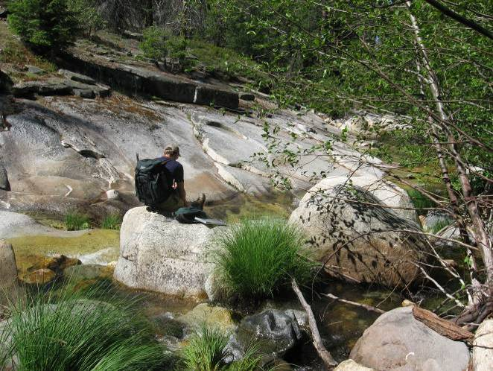
Other aquatic habitat characteristics, species observations, drawings, or comments:

Creek runs through a pine forest. No bullfrogs or other predators observed.

California Red-Legged Frog Habitat Site Assessment Data Sheet

Site Assessment reviewed by:
(FWS Field Office) |  |  |  |  | (Date) |  |  |  |  | (Biologist)
Date of Site Assessment: |  |  |  |  | 8/29/2007
 |  |  |  |  | (mm/dd/yyyy)
Site Assessment Biologists |  |  |  |  | Graf, Peter
 |  |  |  |  | (Last name) |  |  | (First Name) |  | (Last name) |  |  | (First Name)
 |  |  |  |  | (Last name) |  |  | (First Name) |  | (Last name) |  |  | (First Name)
Site Location: |  |  | Placer County, Duncan Creek, 10S 712456, 4323952
 |  |  | (County, general location name, GPS coordinates)
**ATTACH A MAP (include habitat types, important features, and species location)**
Proposed project name: |  |  |  | Placer County Water Agency – Middle Fork American River Project
Brief description of proposed action:

PCWA owns and operates the MFP, a multi-purpose water supply and hydroelectric project designed to control and conserve waters of the Middle Fork American River, the and Rubicon River, and several associated tributary streams. The MFP system consists of two major storage reservoirs, five smaller regulating reservoirs and diversion pools, and five powerhouses and supplies water for homes, industry, and agriculture within western Placer County. PCWA operates the MFP under the terms of the FERC License No. 2079. The current license will expire on February 28, 2013, and PCWA will be seeking a new license for the MFP pursuant to the FERC’s ILP regulations.

1) Is this site within the current or historic range of the CRF (circle one) |  |  |  |  |  |  |  |  |  |  |  |  | Yes | No
2) Are there known records of CRF within 1.6 km (1 mi) of the site (circle one) |  |  |  |  |  |  |  |  |  |  |  |  | Yes | No
If yes, attach a list of all known CRF records with a map showing all locations.

GENERAL AQUATIC HABITAT CHARACTERIZATION

(If multiple ponds or streams are within the proposed action area, fill out one data sheet for each)

POND HABITAT:

Size: |  |  |  |  |  |  | Maximum depth:
Vegetation: emergent, overhanging, dominant species:
Substrate:
Perennial or Ephemeral (circle one) |  |  |  |  |  | If ephemeral, date it goes dry:

STREAM HABITAT:

Width (bank full): |  |  |  | 33 to 53 feet
Depth (bank full): |  |  |  | 1.3 to 9.2 feet
Stream gradient (percent slope): |  |  |  |  |  | >3%
Are there pools (circle one): |  |  |  | Yes |  |  | No
 | If yes,
 | Size of stream pools: |  |  |  | 40 to 75 feet long
 | Maximum depth of stream pools: |  |  |  |  |  |  |  | 5.5 feet
Characterize non-pool habitat: run, riffle, glide, other: |  |  |  |  |  |  |  |  |  |  | Waterfalls and cascades, inter-
-rupted by plunge pools.
Vegetation: emergent, overhanging, dominant species: |  |  |  |  |  |  |  |  |  | No emergent or floating vegetation.
Riparian vegetation includes sparse alders and some forb species along the stream margin.
Canopy cover is approximately 25%.
Substrate: |  | Bedrock, boulder, and cobble
Bank description: |  |  | Stream is steep, confined, and bedrock-dominated. Banks are steep and
rocky, generally not vegetated.
Perennial or Ephemeral (circle one) |  |  |  |  |  |  |  | If ephemeral, date it goes dry:
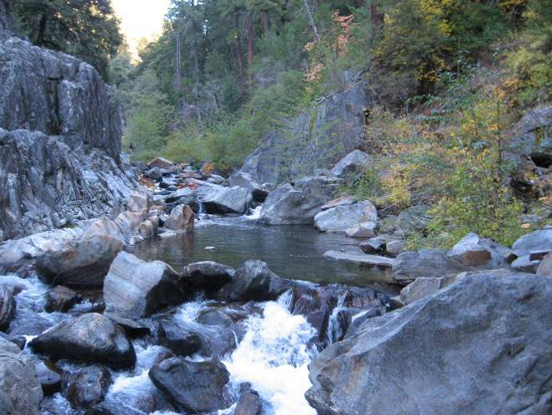
Other aquatic habitat characteristics, species observations, drawings, or comments:

Upper Duncan Creek is above 5,000 feet in elevation

California Red-Legged Frog Habitat Site Assessment Data Sheet

Site Assessment reviewed by:
(FWS Field Office) |  |  |  |  | (Date) |  |  |  |  | (Biologist)
Date of Site Assessment: |  |  |  |  | 08/15/2007
 |  |  |  |  | (mm/dd/yyyy)
Site Assessment Biologists |  |  |  |  | Gillespie, Sara |  |  |  |  | Tucker, Steve
 |  |  |  |  | (Last name) |  |  | (First Name) |  | (Last name) |  |  | (First Name)
 |  |  |  |  | (Last name) |  |  | (First Name) |  | (Last name) |  |  | (First Name)
Site Location: |  |  | Placer County, South Fork Long Canyon Creek Diversion Pool  10S 718882, 4325530
 |  |  | (County, general location name, GPS coordinates)
**ATTACH A MAP (include habitat types, important features, and species location)**
Proposed project name: |  |  |  | Placer County Water Agency – Middle Fork American River Project
Brief description of proposed action:

PCWA owns and operates the MFP, a multi-purpose water supply and hydroelectric project designed to control and conserve waters of the Middle Fork American River, the and Rubicon River, and several associated tributary streams. The MFP system consists of two major storage reservoirs, five smaller regulating reservoirs and diversion pools, and five powerhouses and supplies water for homes, industry, and agriculture within western Placer County. PCWA operates the MFP under the terms of the FERC License No. 2079. The current license will expire on February 28, 2013, and PCWA will be seeking a new license for the MFP pursuant to the FERC’s ILP regulations.

1) Is this site within the current or historic range of the CRF (circle one) |  |  |  |  |  |  |  |  |  |  |  |  | Yes | No
2) Are there known records of CRF within 1.6 km (1 mi) of the site (circle one) |  |  |  |  |  |  |  |  |  |  |  |  | Yes | No
If yes, attach a list of all known CRF records with a map showing all locations.

GENERAL AQUATIC HABITAT CHARACTERIZATION

(If multiple ponds or streams are within the proposed action area, fill out one data sheet for each)

POND HABITAT:

Size: | .42 acres |  |  |  |  |  | Maximum depth: |  |  |  | ~ 25 ft *
Vegetation: emergent, overhanging, dominant species: |  |  |  |  |  |  |  |  | The diversion pool is lined with
trees including several black oaks and pines. Annual grasses/non-native herbaceous species line
the banks of the diversion pool
Substrate: |  | Mud and silt sediments have accumulated in the bottom of the diversion pool
Perennial or Ephemeral (circle one) |  |  |  |  |  | If ephemeral, date it goes dry: |  |  |  |  |  | July*

STREAM HABITAT:

Width (bank full):
Depth (bank full):
Stream gradient (percent slope):
Are there pools (circle one): |  |  |  | Yes |  |  | No
 | If yes,
 | Size of stream pools:
 | Maximum depth of stream pools:
Characterize non-pool habitat: run, riffle, glide, other:
Vegetation: emergent, overhanging, dominant species:
Substrate:
Bank description:
Perennial or Ephemeral (circle one) |  |  |  |  |  |  |  | If ephemeral, date it goes dry:
Other aquatic habitat characteristics, species observations, drawings, or comments:

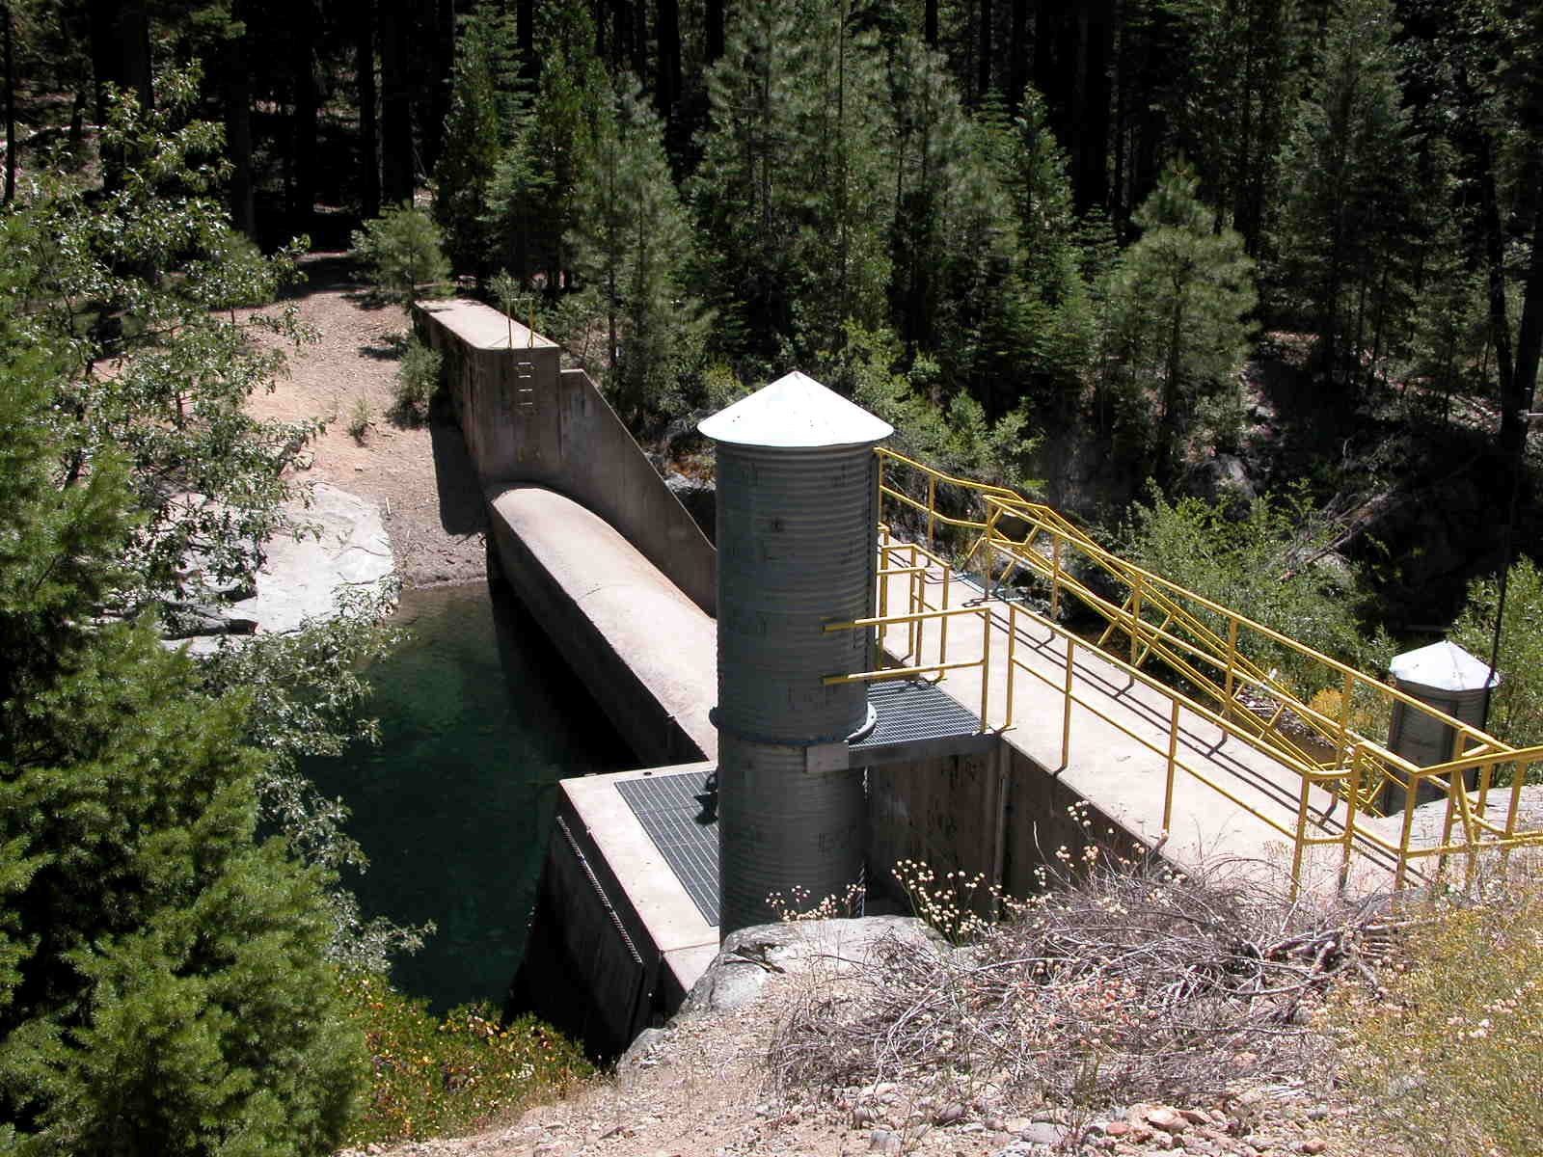
** The SF Long Canyon Creek Diversion Dam is approx. 27 feet high. Water may get as deep as the height of the dam while water is diverted through the pool. However, PCWA stops water from diverting through the diversion pool in July of each year. At the time this survey was conducted (August), water in the pool was less than 1 foot deep, with some areas of exposed mud/dirt. Thus, water does not remain in the diversion long enough to support a breeding population of CRLF.

(Photo provided here was taken in spring of 2007, while there was water in the diversion pool)

California Red-Legged Frog Habitat Site Assessment Data Sheet

Site Assessment reviewed by:
(FWS Field Office) |  |  |  |  | (Date) |  |  |  |  | (Biologist)
Date of Site Assessment: |  |  |  |  | 8/15/2007
 |  |  |  |  | (mm/dd/yyyy)
Site Assessment Biologists |  |  |  |  | Gillespie, Sara |  |  |  |  | Tucker, Steve
 |  |  |  |  | (Last name) |  |  | (First Name) |  | (Last name) |  |  | (First Name)
 |  |  |  |  | (Last name) |  |  | (First Name) |  | (Last name) |  |  | (First Name)
Site Location: |  |  | Placer County, North Fork Long Canyon Diversion Pool,  10S 717940, 4325461
 |  |  | (County, general location name, GPS coordinates)
**ATTACH A MAP (include habitat types, important features, and species location)**
Proposed project name: |  |  |  | Placer County Water Agency – Middle Fork American River Project
Brief description of proposed action:

PCWA owns and operates the MFP, a multi-purpose water supply and hydroelectric project designed to control and conserve waters of the Middle Fork American River, the and Rubicon River, and several associated tributary streams. The MFP system consists of two major storage reservoirs, five smaller regulating reservoirs and diversion pools, and five powerhouses and supplies water for homes, industry, and agriculture within western Placer County. PCWA operates the MFP under the terms of the FERC License No. 2079. The current license will expire on February 28, 2013, and PCWA will be seeking a new license for the MFP pursuant to the FERC’s ILP regulations.

1) Is this site within the current or historic range of the CRF (circle one) |  |  |  |  |  |  |  |  |  |  |  |  | Yes | No
2) Are there known records of CRF within 1.6 km (1 mi) of the site (circle one) |  |  |  |  |  |  |  |  |  |  |  |  | Yes | No
If yes, attach a list of all known CRF records with a map showing all locations.

GENERAL AQUATIC HABITAT CHARACTERIZATION

(If multiple ponds or streams are within the proposed action area, fill out one data sheet for each)

POND HABITAT:

Size: | .72 acres |  |  |  |  |  | Maximum depth: |  |  |  | ~ 10 feet*
Vegetation: emergent, overhanging, dominant species: |  |  |  |  |  |  |  |  | Banks and floor of pool are lined
with annual grasses and other weedy herbaceous species. There are several small willow shrubs
in the diversion itself.
Substrate: |  | Mud and silt sediments have accumulated in the bottom of the diversion pool
Perennial or Ephemeral (circle one) |  |  |  |  |  | If ephemeral, date it goes dry: |  |  |  |  |  | July*

STREAM HABITAT:

Width (bank full):
Depth (bank full):
Stream gradient (percent slope):
Are there pools (circle one): |  |  |  | Yes |  |  | No
 | If yes,
 | Size of stream pools:
 | Maximum depth of stream pools:
Characterize non-pool habitat: run, riffle, glide, other:
Vegetation: emergent, overhanging, dominant species:
Substrate:
Bank description:
Perennial or Ephemeral (circle one) |  |  |  |  |  |  |  | If ephemeral, date it goes dry:
Other aquatic habitat characteristics, species observations, drawings, or comments:

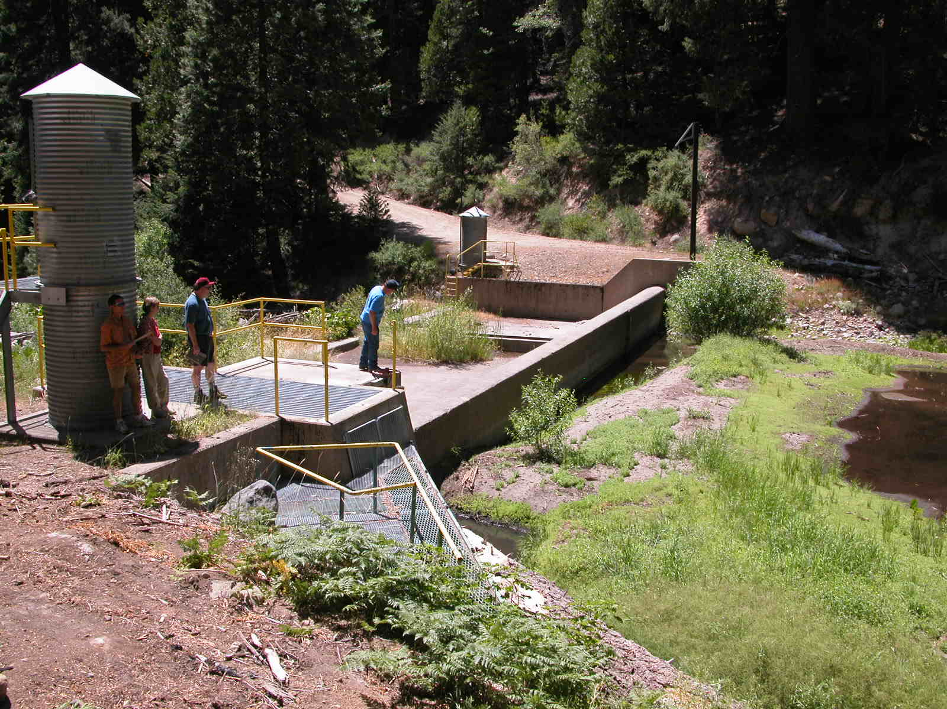
** The NF Long Canyon Creek Diversion Dam is approx. 10 feet high. Water may get as deep as the height of the dam while water is diverted through the pool. However, PCWA stops water from diverting through the diversion pool in July of each year. At the time this survey was conducted (August), water in the pool was less than 1 foot deep, with some areas of exposed mud/dirt. Thus, water does not remain in the diversion long enough to support a breeding population of CRLF.

California Red-Legged Frog Habitat Site Assessment Data Sheet

Site Assessment reviewed by:
(FWS Field Office) |  |  |  |  | (Date) |  |  |  |  | (Biologist)
Date of Site Assessment: |  |  |  |  | 08/24/2007
 |  |  |  |  | (mm/dd/yyyy)
Site Assessment Biologists |  |  |  |  | Barry, Sean |  |  |  |  | Hendrickson, Ann
 |  |  |  |  | (Last name) |  |  | (First Name) |  | (Last name) |  |  | (First Name)
 |  |  |  |  | (Last name) |  |  | (First Name) |  | (Last name) |  |  | (First Name)
Site Location: |  |  | El Dorado, Pond “A”, Auburn SRA, 10S 0671188, 4306389 (NAD 83)
 |  |  | (County, general location name, GPS coordinates)
**ATTACH A MAP (include habitat types, important features, and species location)**
Proposed project name: |  |  |  | Placer County Water Agency – Middle Fork American River Project
Brief description of proposed action:

PCWA owns and operates the MFP, a multi-purpose water supply and hydroelectric project designed to control and conserve waters of the Middle Fork American River, the and Rubicon River, and several associated tributary streams. The MFP system consists of two major storage reservoirs, five smaller regulating reservoirs and diversion pools, and five powerhouses and supplies water for homes, industry, and agriculture within western Placer County. PCWA operates the MFP under the terms of the FERC License No. 2079. The current license will expire on February 28, 2013, and PCWA will be seeking a new license for the MFP pursuant to the FERC’s ILP regulations.

1) Is this site within the current or historic range of the CRF (circle one) |  |  |  |  |  |  |  |  |  |  |  |  | Yes | No
2) Are there known records of CRF within 1.6 km (1 mi) of the site (circle one) |  |  |  |  |  |  |  |  |  |  |  |  | Yes | No
If yes, attach a list of all known CRF records with a map showing all locations.

GENERAL AQUATIC HABITAT CHARACTERIZATION

(If multiple ponds or streams are within the proposed action area, fill out one data sheet for each)

POND HABITAT:

Size: | 80 ft x 80 ft |  |  |  |  |  | Maximum depth: |  |  |  | 15 ft
Vegetation: emergent, overhanging, dominant species:
Floating vegetation: Potamogeton sp., Emergent vegetation: Typha sp. Rubus discolor along west
edge.
Substrate: |  | Silt
Perennial or Ephemeral (circle one) |  |  |  |  |  | If ephemeral, date it goes dry: |  |  |  |  |  | N/A

STREAM HABITAT:

Width (bank full):
Depth (bank full):
Stream gradient (percent slope):
Are there pools (circle one): |  |  |  | Yes |  |  | No
 | If yes,
 | Size of stream pools:
 | Maximum depth of stream pools:
Characterize non-pool habitat: run, riffle, glide, other:
Vegetation: emergent, overhanging, dominant species:
Substrate:
Bank description:
Perennial or Ephemeral (circle one) |  |  |  |  |  |  |  | If ephemeral, date it goes dry:
Other aquatic habitat characteristics, species observations, drawings, or comments:
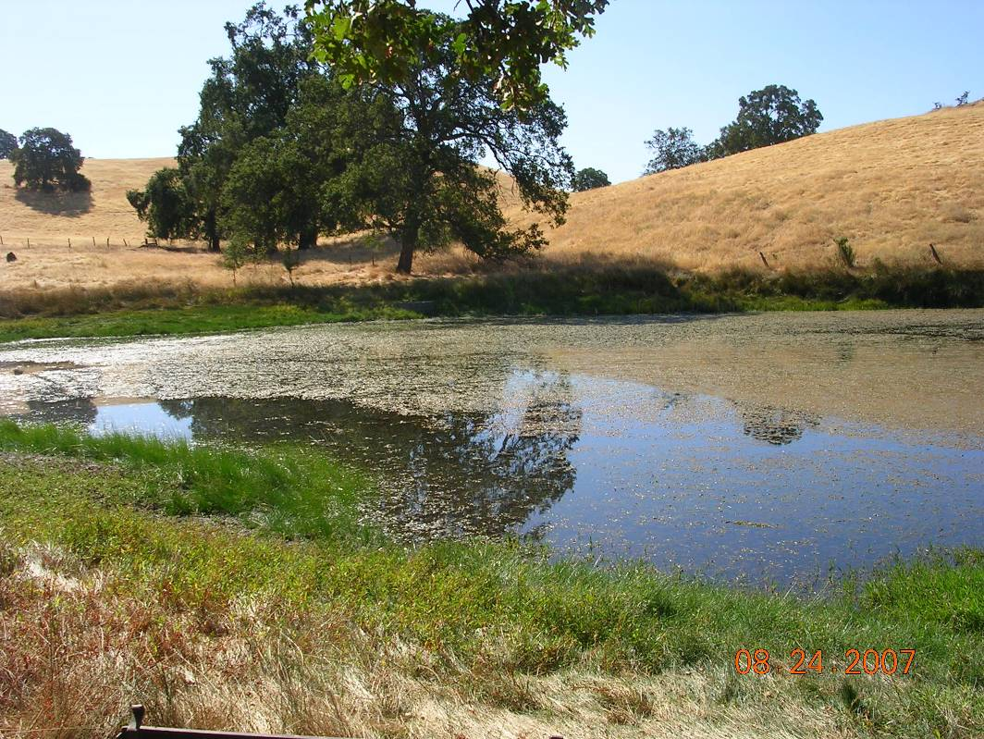
Man-made pond, possibly for cattle. Dam at west edge of pond. Many bullfrog tadpoles and first year metamorphs detected. Gambusia sp. and bass present. American kestrel, acorn woodpecker, mallard, pied-billed grebe, bobcat observed in area.

California Red-Legged Frog Habitat Site Assessment Data Sheet

Site Assessment reviewed by:
(FWS Field Office) |  |  |  |  | (Date) |  |  |  |  | (Biologist)
Date of Site Assessment: |  |  |  |  | 08/24/2007
 |  |  |  |  | (mm/dd/yyyy)
Site Assessment Biologists |  |  |  |  | Nolan-Summers, Janelle |  |  |  |  | Barry, Sean
 |  |  |  |  | (Last name) |  |  | (First Name) |  | (Last name) |  |  | (First Name)
 |  |  |  |  | (Last name) |  |  | (First Name) |  | (Last name) |  |  | (First Name)
Site Location: |  |  | El Dorado, Pond “B” Sliger Mine Rd, Summit Hill Ranch 1461 Sliger Mine Rd., Greenwood, CA 95635
 |  |  | (County, general location name, GPS coordinates)
**ATTACH A MAP (include habitat types, important features, and species location)**
Proposed project name: |  |  |  | Placer County Water Agency – Middle Fork American River Project
Brief description of proposed action:

PCWA owns and operates the MFP, a multi-purpose water supply and hydroelectric project designed to control and conserve waters of the Middle Fork American River, the and Rubicon River, and several associated tributary streams. The MFP system consists of two major storage reservoirs, five smaller regulating reservoirs and diversion pools, and five powerhouses and supplies water for homes, industry, and agriculture within western Placer County. PCWA operates the MFP under the terms of the FERC License No. 2079. The current license will expire on February 28, 2013, and PCWA will be seeking a new license for the MFP pursuant to the FERC’s ILP regulations.

1) Is this site within the current or historic range of the CRF (circle one) |  |  |  |  |  |  |  |  |  |  |  |  | Yes | No
2) Are there known records of CRF within 1.6 km (1 mi) of the site (circle one) |  |  |  |  |  |  |  |  |  |  |  |  | Yes | No
If yes, attach a list of all known CRF records with a map showing all locations.

GENERAL AQUATIC HABITAT CHARACTERIZATION

(If multiple ponds or streams are within the proposed action area, fill out one data sheet for each)

POND HABITAT:

Size: |  |  |  |  |  |  | Maximum depth:
Vegetation: emergent, overhanging, dominant species:
Substrate:
Perennial or Ephemeral (circle one) |  |  |  |  |  | If ephemeral, date it goes dry:

STREAM HABITAT:

Width (bank full):
Depth (bank full):
Stream gradient (percent slope):
Are there pools (circle one): |  |  |  | Yes |  |  | No
 | If yes,
 | Size of stream pools:
 | Maximum depth of stream pools:
Characterize non-pool habitat: run, riffle, glide, other:
Vegetation: emergent, overhanging, dominant species:
Substrate:
Bank description:
Perennial or Ephemeral (circle one) |  |  |  |  |  |  |  | If ephemeral, date it goes dry:
Other aquatic habitat characteristics, species observations, drawings, or comments:

Private Property – unable to obtain access
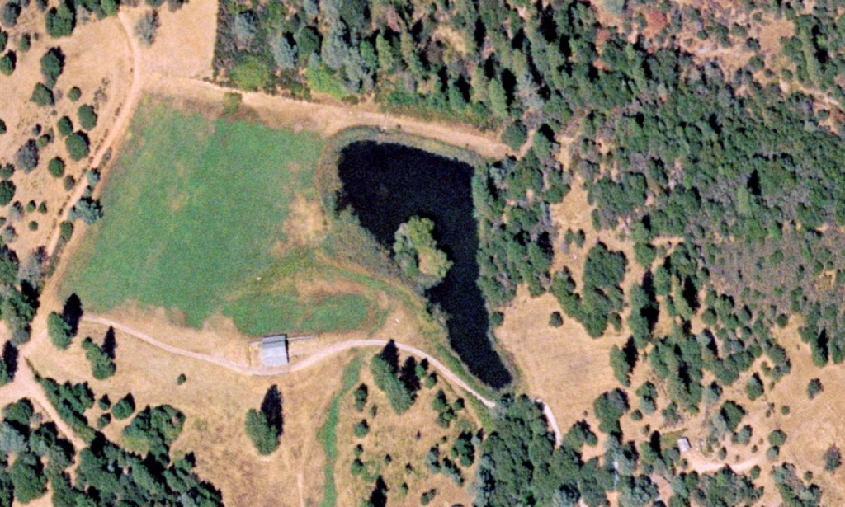
Summit Hill Ranch
Rod Williams Highland Cattle
1461 Sliger Mine Rd.
Greenwood, CA 95635

California Red-Legged Frog Habitat Site Assessment Data Sheet

Site Assessment reviewed by:
(FWS Field Office) |  |  |  |  |  |  |  | (Date) |  |  |  |  |  |  |  |  |  |  | (Biologist)
Date of Site Assessment: |  |  |  |  |  |  |  | 08/24/2007
 |  |  |  |  |  |  |  | (mm/dd/yyyy)
Site Assessment Biologists |  |  |  |  |  |  |  | Nolan-Summers, Janelle |  |  |  |  |  |  |  |  |  |  | Barry, Sean
 |  |  |  |  |  |  |  | (Last name) |  |  |  |  |  |  | (First Name) |  |  |  | (Last name) |  |  |  | (First Name)
 |  |  |  |  |  |  |  | (Last name) |  |  |  |  |  |  | (First Name) |  |  |  | (Last name) |  |  |  | (First Name)
Site Location: |  |  |  |  | El Dorado, Pond “C”, Horseshoe Bar, 10S 0693375, 4319879 (NAD 83)
 |  |  |  |  | (County, general location name, GPS coordinates)
**ATTACH A MAP (include habitat types, important features, and species location)**
Proposed project name: |  |  |  |  |  |  | Placer County Water Agency – Middle Fork American River Project
Brief description of proposed action:

PCWA owns and operates the MFP, a multi-purpose water supply and hydroelectric project designed to control and conserve waters of the Middle Fork American River, the and Rubicon River, and several associated tributary streams. The MFP system consists of two major storage reservoirs, five smaller regulating reservoirs and diversion pools, and five powerhouses and supplies water for homes, industry, and agriculture within western Placer County. PCWA operates the MFP under the terms of the FERC License No. 2079. The current license will expire on February 28, 2013, and PCWA will be seeking a new license for the MFP pursuant to the FERC’s ILP regulations.

1) Is this site within the current or historic range of the CRF (circle one) |  |  |  |  |  |  |  |  |  |  |  |  |  |  |  |  |  |  |  |  |  |  | Yes | No
2) Are there known records of CRF within 1.6 km (1 mi) of the site (circle one) |  |  |  |  |  |  |  |  |  |  |  |  |  |  |  |  |  |  |  |  |  |  | Yes | No
If yes, attach a list of all known CRF records with a map showing all locations.

GENERAL AQUATIC HABITAT CHARACTERIZATION

(If multiple ponds or streams are within the proposed action area, fill out one data sheet for each)

POND HABITAT:

Size: | 15 ft X 50 ft |  |  |  |  |  |  |  |  |  |  |  |  | Maximum depth: |  |  |  |  |  | 2 ft
Vegetation: emergent, overhanging, dominant species:
No floating or emergent vegetation
Substrate: |  |  | Unknown
Perennial or Ephemeral (circle one) |  |  |  |  |  |  |  |  |  |  | If ephemeral, date it goes dry: |  |  |  |  |  |  |  |  |  | N/A
STREAM HABITAT:

Width (bank full):
Depth (bank full):
Stream gradient (percent slope):
Are there pools (circle one): |  |  |  |  |  |  |  | Yes |  |  |  | No
 |  | If yes,
 |  | Size of stream pools:
 |  | Maximum depth of stream pools:
Characterize non-pool habitat: run, riffle, glide, other:
Vegetation: emergent, overhanging, dominant species:
Substrate:
Bank description:
Perennial or Ephemeral (circle one) |  |  |  |  |  |  |  |  |  |  |  |  | If ephemeral, date it goes dry:
Other aquatic habitat characteristics, species observations, drawings, or comments:
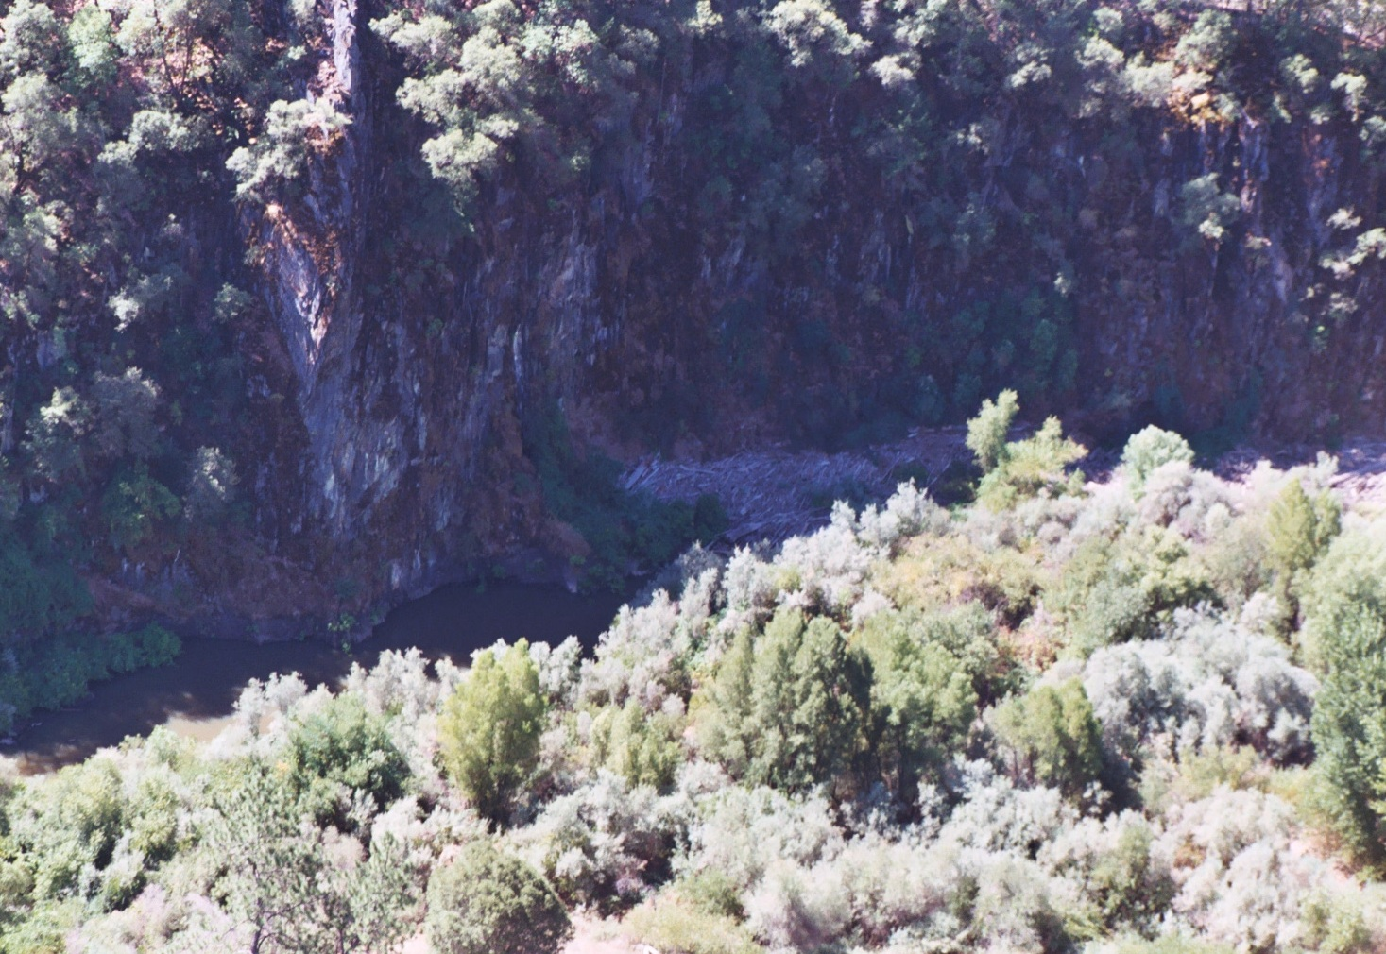
Wide spot in seasonal drainage, pond developed in last year or two by beaver. Bordered by canyon wall on one side. Unable to access pond on ground trail on opposite side of pond (trail goes along the canyon wall). Visible from canyon wall only.

California Red-Legged Frog Habitat Site Assessment Data Sheet

Site Assessment reviewed by:
(FWS Field Office) |  |  |  |  |  |  |  | (Date) |  |  |  |  |  |  |  |  |  |  | (Biologist)
Date of Site Assessment: |  |  |  |  |  |  |  | 08/24/2007
 |  |  |  |  |  |  |  | (mm/dd/yyyy)
Site Assessment Biologists |  |  |  |  |  |  |  | Nolan-Summers, Janelle |  |  |  |  |  |  |  |  |  |  | Barry, Sean
 |  |  |  |  |  |  |  | (Last name) |  |  |  |  |  |  | (First Name) |  |  |  | (Last name) |  |  |  | (First Name)
 |  |  |  |  |  |  |  | (Last name) |  |  |  |  |  |  | (First Name) |  |  |  | (Last name) |  |  |  | (First Name)
Site Location: |  |  |  |  | El Dorado, Pond “D”, Horseshoe Bar, 10S 0693943, 4319370 (NAD 83)
 |  |  |  |  | (County, general location name, GPS coordinates)
**ATTACH A MAP (include habitat types, important features, and species location)**
Proposed project name: |  |  |  |  |  |  | Placer County Water Agency – Middle Fork American River Project
Brief description of proposed action:

PCWA owns and operates the MFP, a multi-purpose water supply and hydroelectric project designed to control and conserve waters of the Middle Fork American River, the and Rubicon River, and several associated tributary streams. The MFP system consists of two major storage reservoirs, five smaller regulating reservoirs and diversion pools, and five powerhouses and supplies water for homes, industry, and agriculture within western Placer County. PCWA operates the MFP under the terms of the FERC License No. 2079. The current license will expire on February 28, 2013, and PCWA will be seeking a new license for the MFP pursuant to the FERC’s ILP regulations.

1) Is this site within the current or historic range of the CRF (circle one) |  |  |  |  |  |  |  |  |  |  |  |  |  |  |  |  |  |  |  |  |  |  | Yes | No
2) Are there known records of CRF within 1.6 km (1 mi) of the site (circle one) |  |  |  |  |  |  |  |  |  |  |  |  |  |  |  |  |  |  |  |  |  |  | Yes | No
If yes, attach a list of all known CRF records with a map showing all locations.

GENERAL AQUATIC HABITAT CHARACTERIZATION

(If multiple ponds or streams are within the proposed action area, fill out one data sheet for each)

POND HABITAT:

Size: | ~1 acre |  |  |  |  |  |  |  |  |  |  |  |  | Maximum depth: |  |  |  |  |  | 20 ft
Vegetation: emergent, overhanging, dominant species: |  |  |  |  |  |  |  |  |  |  |  |  |  |  |  |  |  | No floating or overhanging
vegetation. Salix spp. including button and gray willow (dominant), Rubus discolor, Eriodictyon
angustifolium, Cephalanthus occidentalis, Vitis californica.
Substrate: |  |  | Silt
Perennial or Ephemeral (circle one) |  |  |  |  |  |  |  |  |  |  | If ephemeral, date it goes dry: |  |  |  |  |  |  |  |  |  | N/A
STREAM HABITAT:

Width (bank full):
Depth (bank full):
Stream gradient (percent slope):
Are there pools (circle one): |  |  |  |  |  |  |  | Yes |  |  |  | No
 |  | If yes,
 |  | Size of stream pools:
 |  | Maximum depth of stream pools:
Characterize non-pool habitat: run, riffle, glide, other:
Vegetation: emergent, overhanging, dominant species:
Substrate:
Bank description:
Perennial or Ephemeral (circle one) |  |  |  |  |  |  |  |  |  |  |  |  | If ephemeral, date it goes dry:
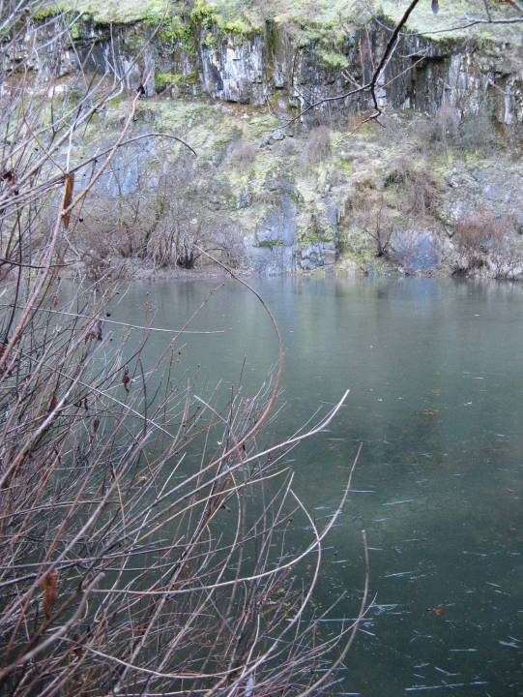
Other aquatic habitat characteristics, species observations, drawings, or comments:

Old mining pond. Vertical edge.

California Red-Legged Frog Habitat Site Assessment Data Sheet

Site Assessment reviewed by:
(FWS Field Office) |  |  |  |  | (Date) |  |  |  |  | (Biologist)
Date of Site Assessment: |  |  |  |  | 12/08/2007
 |  |  |  |  | (mm/dd/yyyy)
Site Assessment Biologists |  |  |  |  | Nolan-Summers, Janelle |  |  |  |  | Gillespie, Sara
 |  |  |  |  | (Last name) |  |  | (First Name) |  | (Last name) |  |  | (First Name)
 |  |  |  |  | (Last name) |  |  | (First Name) |  | (Last name) |  |  | (First Name)
Site Location: |  |  | El Dorado, Pond “D”, Horseshoe Bar, 10S 0693943, 4319370 (NAD 83)
 |  |  | (County, general location name, GPS coordinates)
**ATTACH A MAP (include habitat types, important features, and species location)**
Proposed project name: |  |  |  | Placer County Water Agency – Middle Fork American River Project
Brief description of proposed action:

PCWA owns and operates the MFP, a multi-purpose water supply and hydroelectric project designed to control and conserve waters of the Middle Fork American River, the and Rubicon River, and several associated tributary streams. The MFP system consists of two major storage reservoirs, five smaller regulating reservoirs and diversion pools, and five powerhouses and supplies water for homes, industry, and agriculture within western Placer County. PCWA operates the MFP under the terms of the FERC License No. 2079. The current license will expire on February 28, 2013, and PCWA will be seeking a new license for the MFP pursuant to the FERC’s ILP regulations.

1) Is this site within the current or historic range of the CRF (circle one) |  |  |  |  |  |  |  |  |  |  |  |  | Yes | No
2) Are there known records of CRF within 1.6 km (1 mi) of the site (circle one) |  |  |  |  |  |  |  |  |  |  |  |  | Yes | No
If yes, attach a list of all known CRF records with a map showing all locations.

GENERAL AQUATIC HABITAT CHARACTERIZATION

(If multiple ponds or streams are within the proposed action area, fill out one data sheet for each)

POND HABITAT:

Size: | 35 feet wide x 375 feet |  |  |  |  |  | Maximum depth: |  |  |  | 5-6 feet
Vegetation: emergent, overhanging, dominant species: |  |  |  |  |  |  |  |  | No floating vegetation.
Salix sp. (dominant), Rubus discolor, Eriodictyon angustifolium, Vitis californica.
Cephalanthus occidentalis,
Substrate: |  | Silt and organic matter
Perennial or Ephemeral (circle one) |  |  |  |  |  | If ephemeral, date it goes dry:

STREAM HABITAT:

Width (bank full):
Depth (bank full):
Stream gradient (percent slope):
Are there pools (circle one): |  |  |  | Yes |  |  | No
 | If yes,
 | Size of stream pools:
 | Maximum depth of stream pools:
Characterize non-pool habitat: run, riffle, glide, other:
Vegetation: emergent, overhanging, dominant species:
Substrate:
Bank description:
Perennial or Ephemeral (circle one) |  |  |  |  |  |  |  | If ephemeral, date it goes dry:
Other aquatic habitat characteristics, species observations, drawings, or comments:

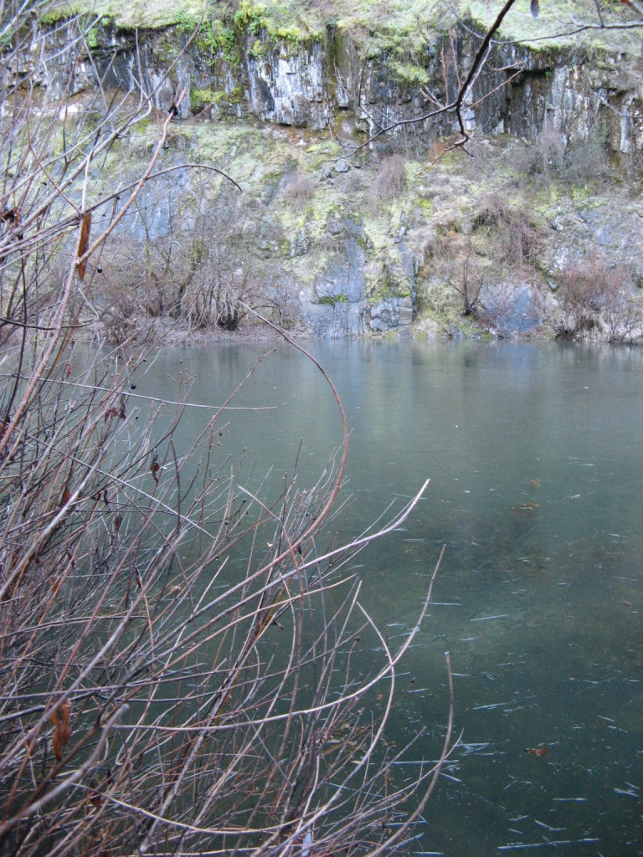
Sheer cliff face on south side. Photos 761 to 764

California Red-Legged Frog Habitat Site Assessment Data Sheet

Site Assessment reviewed by:
(FWS Field Office) |  |  |  |  | (Date) |  |  |  |  | (Biologist)
Date of Site Assessment: |  |  |  |  | 08/24/2007
 |  |  |  |  | (mm/dd/yyyy)
Site Assessment Biologists |  |  |  |  | Nolan-Summers, Janelle |  |  |  |  | Barry, Sean
 |  |  |  |  | (Last name) |  |  | (First Name) |  | (Last name) |  |  | (First Name)
 |  |  |  |  | (Last name) |  |  | (First Name) |  | (Last name) |  |  | (First Name)
Site Location: |  |  | El Dorado County, Pond “E”, Horseshoe Bar, 10S 0694051 4319686 (NAD 83)
 |  |  | (County, general location name, GPS coordinates)
**ATTACH A MAP (include habitat types, important features, and species location)**
Proposed project name: |  |  |  | Placer County Water Agency – Middle Fork American River Project
Brief description of proposed action:

PCWA owns and operates the MFP, a multi-purpose water supply and hydroelectric project designed to control and conserve waters of the Middle Fork American River, the and Rubicon River, and several associated tributary streams. The MFP system consists of two major storage reservoirs, five smaller regulating reservoirs and diversion pools, and five powerhouses and supplies water for homes, industry, and agriculture within western Placer County. PCWA operates the MFP under the terms of the FERC License No. 2079. The current license will expire on February 28, 2013, and PCWA will be seeking a new license for the MFP pursuant to the FERC’s ILP regulations.

1) Is this site within the current or historic range of the CRF (circle one) |  |  |  |  |  |  |  |  |  |  |  |  | Yes | No
2) Are there known records of CRF within 1.6 km (1 mi) of the site (circle one) |  |  |  |  |  |  |  |  |  |  |  |  | Yes | No
If yes, attach a list of all known CRF records with a map showing all locations.

GENERAL AQUATIC HABITAT CHARACTERIZATION

(If multiple ponds or streams are within the proposed action area, fill out one data sheet for each)

POND HABITAT:

Size: | 25 ft wide x 25 ft long |  |  |  |  |  | Maximum depth: |  |  |  | 10 ft
Vegetation: emergent, overhanging, dominant species: |  |  |  |  |  |  |  |  | No emergent or overhanging
Vegetation. Potamogeton sp., indication of cooler water (per S. Barry). Riparian vegetation,
dominated by willows.
Substrate: |  | silt and organic matter
Perennial or Ephemeral (circle one) |  |  |  |  |  | If ephemeral, date it goes dry: |  |  |  |  |  | in dry years only

STREAM HABITAT:

Width (bank full):
Depth (bank full):
Stream gradient (percent slope):
Are there pools (circle one): |  |  |  | Yes |  |  | No
 | If yes,
 | Size of stream pools:
 | Maximum depth of stream pools:
Characterize non-pool habitat: run, riffle, glide, other:
Vegetation: emergent, overhanging, dominant species:
Substrate:
Bank description:
Perennial or Ephemeral (circle one) |  |  |  |  |  |  |  | If ephemeral, date it goes dry:
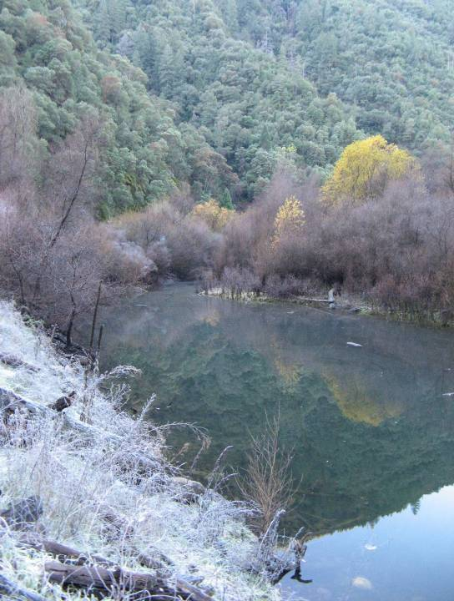
Other aquatic habitat characteristics, species observations, drawings, or comments:

Man-made mining pond. Bullfrog tadpoles observed. Mallard & green heron observed. During winter hydrologically connected to Pond “D”

California Red-Legged Frog Habitat Site Assessment Data Sheet

Site Assessment reviewed by:
(FWS Field Office) |  |  |  |  | (Date) |  |  |  |  | (Biologist)
Date of Site Assessment: |  |  |  |  | 12/08/2007
 |  |  |  |  | (mm/dd/yyyy)
Site Assessment Biologists |  |  |  |  | Nolan-Summers, Janelle |  |  |  |  | Gillespie, Sara
 |  |  |  |  | (Last name) |  |  | (First Name) |  | (Last name) |  |  | (First Name)
 |  |  |  |  | (Last name) |  |  | (First Name) |  | (Last name) |  |  | (First Name)
Site Location: |  |  | El Dorado County, Pond “E”, Horseshoe Bar, 10S 0694051 4319686 (NAD 83); culvert, 10S 0693976 4319615 (NAD 83)
 |  |  | (County, general location name, GPS coordinates)
**ATTACH A MAP (include habitat types, important features, and species location)**
Proposed project name: |  |  |  | Placer County Water Agency – Middle Fork American River Project
Brief description of proposed action:

PCWA owns and operates the MFP, a multi-purpose water supply and hydroelectric project designed to control and conserve waters of the Middle Fork American River, the and Rubicon River, and several associated tributary streams. The MFP system consists of two major storage reservoirs, five smaller regulating reservoirs and diversion pools, and five powerhouses and supplies water for homes, industry, and agriculture within western Placer County. PCWA operates the MFP under the terms of the FERC License No. 2079. The current license will expire on February 28, 2013, and PCWA will be seeking a new license for the MFP pursuant to the FERC’s ILP regulations.

1) Is this site within the current or historic range of the CRF (circle one) |  |  |  |  |  |  |  |  |  |  |  |  | Yes | No
2) Are there known records of CRF within 1.6 km (1 mi) of the site (circle one) |  |  |  |  |  |  |  |  |  |  |  |  | Yes | No
If yes, attach a list of all known CRF records with a map showing all locations.

GENERAL AQUATIC HABITAT CHARACTERIZATION

(If multiple ponds or streams are within the proposed action area, fill out one data sheet for each)

POND HABITAT:

Size: | 30 ft wide x 450 ft long |  |  |  |  |  | Maximum depth: |  |  |  | Current = 3–4 ft ; Max Rainy Season = 6–7 ft
Vegetation: emergent, overhanging, dominant species: |  |  |  |  |  |  |  |  | No emergent or overhanging
vegetation; Rubus discolor, Vitis californica sp., Verbascum thapsus , Rumex sp.
Substrate: |  | silt and organic matter
Perennial or Ephemeral (circle one) |  |  |  |  |  | If ephemeral, date it goes dry: |  |  |  |  |  | in dry years only

STREAM HABITAT:

Width (bank full):
Depth (bank full):
Stream gradient (percent slope):
Are there pools (circle one): |  |  |  | Yes |  |  | No
 | If yes,
 | Size of stream pools:
 | Maximum depth of stream pools:
Characterize non-pool habitat: run, riffle, glide, other:
Vegetation: emergent, overhanging, dominant species:
Substrate:
Bank description:
Perennial or Ephemeral (circle one) |  |  |  |  |  |  |  | If ephemeral, date it goes dry:
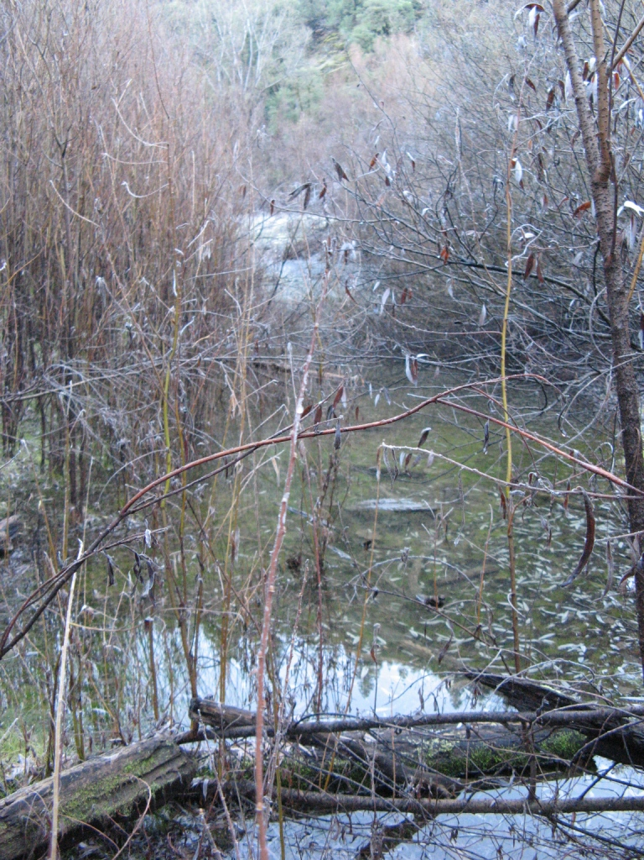
Other aquatic habitat characteristics, species observations, drawings, or comments:

Man-made mining pond. See photos 765 -768. Long pond is shaped like a double-ended teardrop, narrow on either end, widest (~ 30 ft) in the middle. Hydrologically connected in winter (per John Close) at east end to Pond D, by a culvert that runs under dirt road (see illustration). Photos of drainage: 772 and 773.

California Red-Legged Frog Habitat Site Assessment Data Sheet

Site Assessment reviewed by:
(FWS Field Office) |  |  |  |  | (Date) |  |  |  |  | (Biologist)
Date of Site Assessment: |  |  |  |  | 12/08/2007
 |  |  |  |  | (mm/dd/yyyy)
Site Assessment Biologists |  |  |  |  | Nolan-Summers, Janelle |  |  |  |  | Gillespie, Sara
 |  |  |  |  | (Last name) |  |  | (First Name) |  | (Last name) |  |  | (First Name)
 |  |  |  |  | (Last name) |  |  | (First Name) |  | (Last name) |  |  | (First Name)
Site Location: |  |  | El Dorado, Pond “F”, Horseshoe Bar, 10S 0693905, 4319632 (NAD 83)
 |  |  | (County, general location name, GPS coordinates)
**ATTACH A MAP (include habitat types, important features, and species location)**
Proposed project name: |  |  |  | Placer County Water Agency – Middle Fork American River Project
Brief description of proposed action:

PCWA owns and operates the MFP, a multi-purpose water supply and hydroelectric project designed to control and conserve waters of the Middle Fork American River, the and Rubicon River, and several associated tributary streams. The MFP system consists of two major storage reservoirs, five smaller regulating reservoirs and diversion pools, and five powerhouses and supplies water for homes, industry, and agriculture within western Placer County. PCWA operates the MFP under the terms of the FERC License No. 2079. The current license will expire on February 28, 2013, and PCWA will be seeking a new license for the MFP pursuant to the FERC’s ILP regulations.

1) Is this site within the current or historic range of the CRF (circle one) |  |  |  |  |  |  |  |  |  |  |  |  | Yes | No
2) Are there known records of CRF within 1.6 km (1 mi) of the site (circle one) |  |  |  |  |  |  |  |  |  |  |  |  | Yes | No
If yes, attach a list of all known CRF records with a map showing all locations.

GENERAL AQUATIC HABITAT CHARACTERIZATION

(If multiple ponds or streams are within the proposed action area, fill out one data sheet for each)

POND HABITAT:

Size: | 45 ft x 129 ft |  |  |  |  |  | Maximum depth: |  |  |  | ~ 1 ft
Vegetation: emergent, overhanging, dominant species:
Salix sp., Rubus discolor, Vitis sp., annual grass, Calocedrus decurrens.
Substrate: |  | mud – very muddy water
Perennial or Ephemeral (circle one) |  |  |  |  |  | If ephemeral, date it goes dry: |  |  |  |  |  | Late June

STREAM HABITAT:

Width (bank full):
Depth (bank full):
Stream gradient (percent slope):
Are there pools (circle one): |  |  |  | Yes |  |  | No
 | If yes,
 | Size of stream pools:
 | Maximum depth of stream pools:
Characterize non-pool habitat: run, riffle, glide, other:
Vegetation: emergent, overhanging, dominant species:
Substrate:
Bank description:
Perennial or Ephemeral (circle one) |  |  |  |  |  |  |  | If ephemeral, date it goes dry:
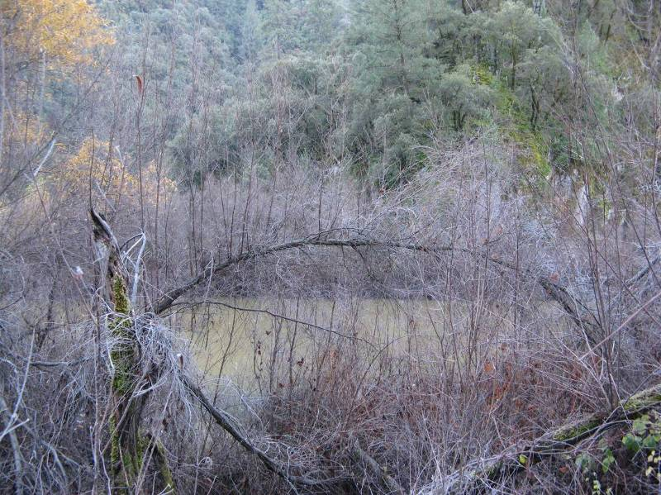
Other aquatic habitat characteristics, species observations, drawings, or comments:

(Photos 775 and 776) Cliff on west side of pond - plunges down. Per John C., the pond dries up in summer (late June). General notes on vegetation: area is characterized by Canyon Live Oak, which is replaced by a pine community (Doug-fir?) at the top of the ridge.

California Red-Legged Frog Habitat Site Assessment Data Sheet

Site Assessment reviewed by:
(FWS Field Office) |  |  |  |  | (Date) |  |  |  |  | (Biologist)
Date of Site Assessment: |  |  |  |  | 08/24/2007
 |  |  |  |  | (mm/dd/yyyy)
Site Assessment Biologists |  |  |  |  | Nolan-Summers, Janelle |  |  |  |  | Barry, Sean
 |  |  |  |  | (Last name) |  |  | (First Name) |  | (Last name) |  |  | (First Name)
 |  |  |  |  | (Last name) |  |  | (First Name) |  | (Last name) |  |  | (First Name)
Site Location: |  |  | El Dorado, Pond “G”, Horseshoe Bar, 10S 0693678, 4319863 (NAD 83)
 |  |  | (County, general location name, GPS coordinates)
**ATTACH A MAP (include habitat types, important features, and species location)**
Proposed project name: |  |  |  | Placer County Water Agency – Middle Fork American River Project
Brief description of proposed action:

PCWA owns and operates the MFP, a multi-purpose water supply and hydroelectric project designed to control and conserve waters of the Middle Fork American River, the and Rubicon River, and several associated tributary streams. The MFP system consists of two major storage reservoirs, five smaller regulating reservoirs and diversion pools, and five powerhouses and supplies water for homes, industry, and agriculture within western Placer County. PCWA operates the MFP under the terms of the FERC License No. 2079. The current license will expire on February 28, 2013, and PCWA will be seeking a new license for the MFP pursuant to the FERC’s ILP regulations.

1) Is this site within the current or historic range of the CRF (circle one) |  |  |  |  |  |  |  |  |  |  |  |  | Yes | No
2) Are there known records of CRF within 1.6 km (1 mi) of the site (circle one) |  |  |  |  |  |  |  |  |  |  |  |  | Yes | No
If yes, attach a list of all known CRF records with a map showing all locations.

GENERAL AQUATIC HABITAT CHARACTERIZATION

(If multiple ponds or streams are within the proposed action area, fill out one data sheet for each)

POND HABITAT:

Size: | ~20 ft wide average |  |  |  |  |  | Maximum depth: |  |  |  | 2 ft now; 8 ft. after rainy season, connected to river in high flows. Gets blown out in floods.
Vegetation: emergent, overhanging, dominant species: |  |  |  |  |  |  |  |  | No overhanging vegetation.
Sedges (very small & bushy), Salix sp., Muhlenbergia rigens
Substrate: |  | sand and granite
Perennial or Ephemeral (circle one) |  |  |  |  |  | If ephemeral, date it goes dry: |  |  |  |  |  | N/A

STREAM HABITAT:

Width (bank full):
Depth (bank full):
Stream gradient (percent slope):
Are there pools (circle one): |  |  |  | Yes |  |  | No
 | If yes,
 | Size of stream pools:
 | Maximum depth of stream pools:
Characterize non-pool habitat: run, riffle, glide, other:
Vegetation: emergent, overhanging, dominant species:
Substrate:
Bank description:
Perennial or Ephemeral (circle one) |  |  |  |  |  |  |  | If ephemeral, date it goes dry:
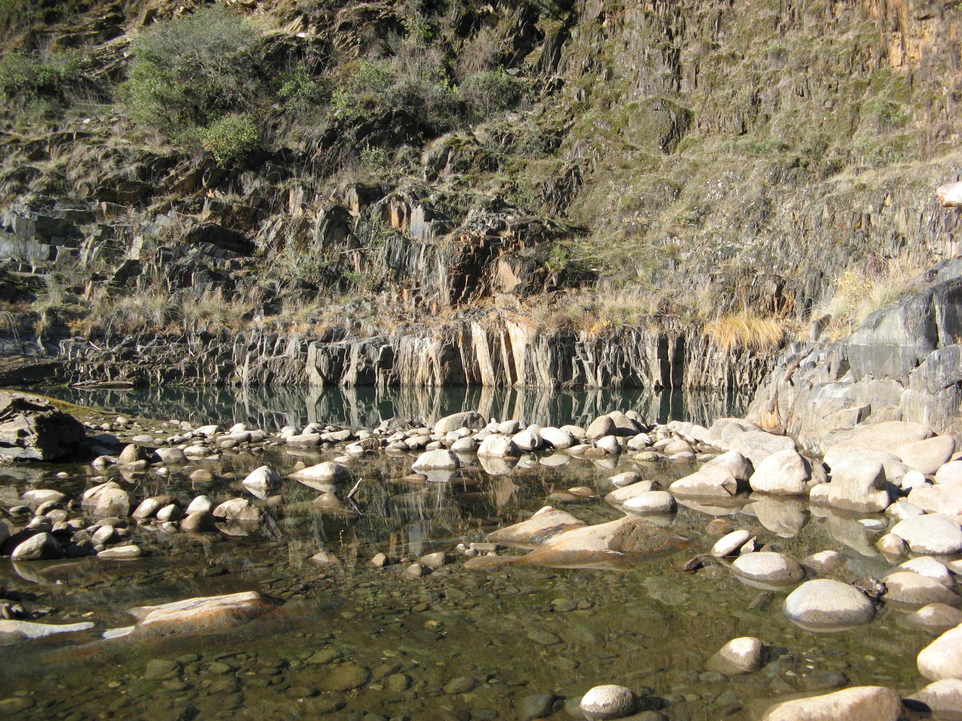
Other aquatic habitat characteristics, species observations, drawings, or comments:

Photos 777 – 781. Granite cliff face one side of pond, sandy on other side of pond. Pond 2 ft deep at time of survey, to 8 feet when water levels are high (rainy). Connected the river in high flows, gets “blown out” during flood events.

California Red-Legged Frog Habitat Site Assessment Data Sheet

Site Assessment reviewed by:
(FWS Field Office) |  |  |  |  | (Date) |  |  |  |  | (Biologist)
Date of Site Assessment: |  |  |  |  | 12/08/2007
 |  |  |  |  | (mm/dd/yyyy)
Site Assessment Biologists |  |  |  |  | Nolan-Summers, Janelle |  |  |  |  | Gillespie, Sara
 |  |  |  |  | (Last name) |  |  | (First Name) |  | (Last name) |  |  | (First Name)
 |  |  |  |  | (Last name) |  |  | (First Name) |  | (Last name) |  |  | (First Name)
Site Location: |  |  | El Dorado, Pond “G”, Horseshoe Bar, 10S 0693678, 4319863 (NAD 83)
 |  |  | (County, general location name, GPS coordinates)
**ATTACH A MAP (include habitat types, important features, and species location)**
Proposed project name: |  |  |  | Placer County Water Agency – Middle Fork American River Project
Brief description of proposed action:

PCWA owns and operates the MFP, a multi-purpose water supply and hydroelectric project designed to control and conserve waters of the Middle Fork American River, the and Rubicon River, and several associated tributary streams. The MFP system consists of two major storage reservoirs, five smaller regulating reservoirs and diversion pools, and five powerhouses and supplies water for homes, industry, and agriculture within western Placer County. PCWA operates the MFP under the terms of the FERC License No. 2079. The current license will expire on February 28, 2013, and PCWA will be seeking a new license for the MFP pursuant to the FERC’s ILP regulations.

1) Is this site within the current or historic range of the CRF (circle one) |  |  |  |  |  |  |  |  |  |  |  |  | Yes | No
2) Are there known records of CRF within 1.6 km (1 mi) of the site (circle one) |  |  |  |  |  |  |  |  |  |  |  |  | Yes | No
If yes, attach a list of all known CRF records with a map showing all locations.

GENERAL AQUATIC HABITAT CHARACTERIZATION

(If multiple ponds or streams are within the proposed action area, fill out one data sheet for each)

POND HABITAT:

Size: | ~20 ft wide average |  |  |  |  |  | Maximum depth: |  |  |  | ~ 2 feet
Vegetation: emergent, overhanging, dominant species:
No emergent or overhanging veg.
Substrate: |  | sandy
Perennial or Ephemeral (circle one) |  |  |  |  |  | If ephemeral, date it goes dry:

STREAM HABITAT:

Width (bank full):
Depth (bank full):
Stream gradient (percent slope):
Are there pools (circle one): |  |  |  | Yes |  |  | No
 | If yes,
 | Size of stream pools:
 | Maximum depth of stream pools:
Characterize non-pool habitat: run, riffle, glide, other:
Vegetation: emergent, overhanging, dominant species:
Substrate:
Bank description:
Perennial or Ephemeral (circle one) |  |  |  |  |  |  |  | If ephemeral, date it goes dry:
Other aquatic habitat characteristics, species observations, drawings, or comments:

Backwater area that is connected to river. Granite walls and bottom (of pond)
Necessary Attachments:
1. All field notes and other supporting documents.
2. Site photographs.
3. Maps with important habitat features and species locations.

California Red-Legged Frog Habitat Site Assessment Data Sheet

Site Assessment reviewed by:
(FWS Field Office) |  |  |  |  | (Date) |  |  |  |  | (Biologist)
Date of Site Assessment: |  |  |  |  | 08/24/2007
 |  |  |  |  | (mm/dd/yyyy)
Site Assessment Biologists |  |  |  |  | Nolan-Summers, Janelle |  |  |  |  | Barry, Sean
 |  |  |  |  | (Last name) |  |  | (First Name) |  | (Last name) |  |  | (First Name)
 |  |  |  |  | (Last name) |  |  | (First Name) |  | (Last name) |  |  | (First Name)
Site Location: |  |  | El Dorado, South Lake and attached backwater area, Horseshoe Bar, 10S 0693601, 4320012 (NAD 83)
 |  |  | (County, general location name, GPS coordinates)
**ATTACH A MAP (include habitat types, important features, and species location)**
Proposed project name: |  |  |  | Placer County Water Agency – Middle Fork American River Project
Brief description of proposed action:

PCWA owns and operates the MFP, a multi-purpose water supply and hydroelectric project designed to control and conserve waters of the Middle Fork American River, the and Rubicon River, and several associated tributary streams. The MFP system consists of two major storage reservoirs, five smaller regulating reservoirs and diversion pools, and five powerhouses and supplies water for homes, industry, and agriculture within western Placer County. PCWA operates the MFP under the terms of the FERC License No. 2079. The current license will expire on February 28, 2013, and PCWA will be seeking a new license for the MFP pursuant to the FERC’s ILP regulations.

1) Is this site within the current or historic range of the CRF (circle one) |  |  |  |  |  |  |  |  |  |  |  |  | Yes | No
2) Are there known records of CRF within 1.6 km (1 mi) of the site (circle one) |  |  |  |  |  |  |  |  |  |  |  |  | Yes | No
If yes, attach a list of all known CRF records with a map showing all locations.

GENERAL AQUATIC HABITAT CHARACTERIZATION

(If multiple ponds or streams are within the proposed action area, fill out one data sheet for each)

POND HABITAT:

Size: | LAKE- 1- 2 acres |  |  |  |  |  | Maximum depth: |  |  |  | 60 ft
Vegetation: emergent, overhanging, dominant species:
No emergent or overhanging vegetation. Some willow spp.
Substrate: |  | silt
Perennial or Ephemeral (circle one) |  |  |  |  |  | If ephemeral, date it goes dry:

STREAM HABITAT:

Width (bank full):
Depth (bank full):
Stream gradient (percent slope):
Are there pools (circle one): |  |  |  | Yes |  |  | No
 | If yes,
 | Size of stream pools:
 | Maximum depth of stream pools:
Characterize non-pool habitat: run, riffle, glide, other:
Vegetation: emergent, overhanging, dominant species:
Substrate:
Bank description:
Perennial or Ephemeral (circle one) |  |  |  |  |  |  |  | If ephemeral, date it goes dry:
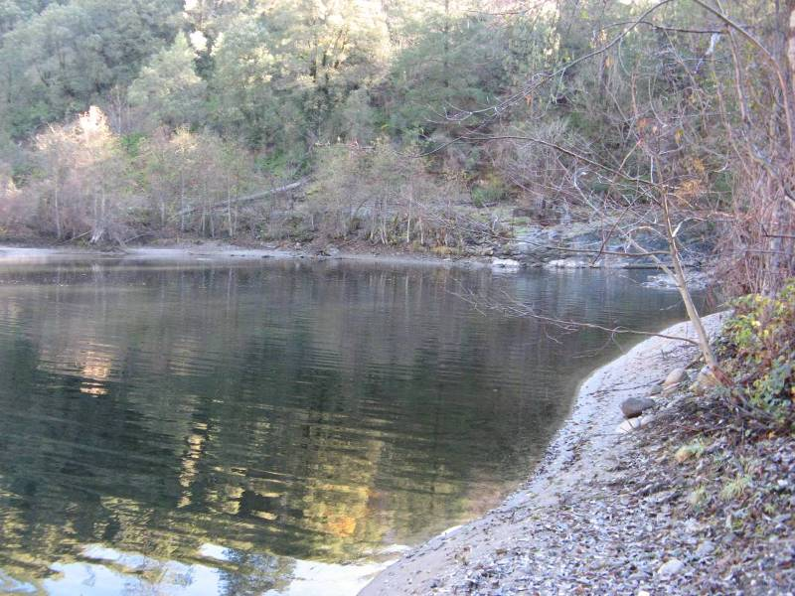
Other aquatic habitat characteristics, species observations, drawings, or comments:

Lake located at end of tunnel chute. Beaver and otter occupy the lake (per caretaker John C.). Small “pond” adjacent to the lake (backwater area, directly connected to the lake). Some willow at edge of lake, on the opposite side. Granite cliffs.

California Red-Legged Frog Habitat Site Assessment Data Sheet

Site Assessment reviewed by:
(FWS Field Office) |  |  |  |  | (Date) |  |  |  |  | (Biologist)
Date of Site Assessment: |  |  |  |  | 12/08/2007
 |  |  |  |  | (mm/dd/yyyy)
Site Assessment Biologists |  |  |  |  | Nolan-Summers, Janelle |  |  |  |  | Gillespie, Sara
 |  |  |  |  | (Last name) |  |  | (First Name) |  | (Last name) |  |  | (First Name)
 |  |  |  |  | (Last name) |  |  | (First Name) |  | (Last name) |  |  | (First Name)
Site Location: |  |  | El Dorado, South Lake, Horseshoe Bar, 10S 0693601, 4320012 (NAD 83)
 |  |  | (County, general location name, GPS coordinates)
**ATTACH A MAP (include habitat types, important features, and species location)**
Proposed project name: |  |  |  | Placer County Water Agency – Middle Fork American River Project
Brief description of proposed action:

PCWA owns and operates the MFP, a multi-purpose water supply and hydroelectric project designed to control and conserve waters of the Middle Fork American River, the and Rubicon River, and several associated tributary streams. The MFP system consists of two major storage reservoirs, five smaller regulating reservoirs and diversion pools, and five powerhouses and supplies water for homes, industry, and agriculture within western Placer County. PCWA operates the MFP under the terms of the FERC License No. 2079. The current license will expire on February 28, 2013, and PCWA will be seeking a new license for the MFP pursuant to the FERC’s ILP regulations.
1) Is this site within the current or historic range of the CRF (circle one) |  |  |  |  |  |  |  |  |  |  |  |  | Yes | No
2) Are there known records of CRF within 1.6 km (1 mi) of the site (circle one) |  |  |  |  |  |  |  |  |  |  |  |  | Yes | No
If yes, attach a list of all known CRF records with a map showing all locations.

GENERAL AQUATIC HABITAT CHARACTERIZATION

(If multiple ponds or streams are within the proposed action area, fill out one data sheet for each)

POND HABITAT:

Size: | LAKE- 1- 2 acres |  |  |  |  |  | Maximum depth: |  |  |  | Current: 30 ft; Maximum: 50 ft
Vegetation: emergent, overhanging, dominant species: |  |  |  |  |  |  |  |  | No vegetation along or in water.
Area surrounded by Alnus sp., Betula sp.; Equisetum sp., Rubus discolor, and
Salix sp. on sandbar
Substrate: |  | silt
Perennial or Ephemeral (circle one) |  |  |  |  |  | If ephemeral, date it goes dry:

STREAM HABITAT:

Width (bank full):
Depth (bank full):
Stream gradient (percent slope):
Are there pools (circle one): |  |  |  | Yes |  |  | No
 | If yes,
 | Size of stream pools:
 | Maximum depth of stream pools:
Characterize non-pool habitat: run, riffle, glide, other:
Vegetation: emergent, overhanging, dominant species:
Substrate:
Bank description:
Perennial or Ephemeral (circle one) |  |  |  |  |  |  |  | If ephemeral, date it goes dry:
Other aquatic habitat characteristics, species observations, drawings, or comments:

Photos thru 785. Photos 786 and 787 show backwater area attached to lake. Lake is very deep. Connected to river, wide spot just on other side of tunnel (photo 791). No attachment to other ponds in area. Photos 788 and 789 show upland vegetation in the area.

Lake has populations of Rainbow, brook, and brown trout (per the caretaker John Close).

Bullfrog detected. American kestrel, wrentit, black phoebe, Stellar’s jay, bushtit, red-tailed hawk detected in area.

